Supplementary materials

Content

Supplementary materials 1

Section 1. Descriptive statistics 1

Section 2: Model layout 15

Section 3. “Standardised separately” & alternative subsets 15

3.1. Standardised separately, full analysis. 15

3.2. Standardised together, analysis without Iranian sample. 17

3.3. Standardised together, analysis without considering skin L* (lightness) as a predictor. 19

Section 4. Bayesian path analyses 22

4.1. Women: 22

4.2. Men 23

4.3. Path Analyses per culture (F = female sample, M = male sample): 24

Section 5: Models based on individual ratings 28

5.1. Model 1 and 2 (changes denoted in the model layout): 28

5.2. Model 3 and 4 (changes denoted in the model layout): 29

5.3 Estimates 30

Section 6: Models with nonlinear terms – results report: 36

6.1. Considered model layout: 37

6.2. Predictions – Data standardised together 42

6.3. Model predictions – Data standardised separately 47

Section 7: Excluding values at the margins – model predictions. 51

7.1. Attractiveness 52

7.2. Sextypicality 54

8. References 55

This material comes with the manuscript “Bright is Not Always Right: Peri-Iridal Brightness Reduces Attractiveness via Perceived Sex-Typicality Across Human Populations”

For data and script, please visit: https://github.com/VojtechFiala/EyeProject_Paper_One

## Section 1. Descriptive statistics

The analysis concerned how the colour and tone of human iris and peri-iridal tissues’ colouration affect perceived attractiveness and sextypicality in human faces of various populations. The distribution of the colour and tone within samples was as follows:



**Figure S1**. Violin plots of distribution of Skin (upper row), Iris (middle row), and Scleral (lowermost row) CIELab L* (lightness) in each population on the original scale (left), when pooled first and then standardised (middle), when standardised within each sample (right). Samples, from left to right, in each plot: Cameroon 2013, Cameroon 2016, Colombia, Czech Republic 2016, Czech Republic, 2019, India (CFD), Iran, Turkey, Vietnam. Both sexes together.

**Figure S2**. Violin plots of distribution of Skin (upper row), Iris (middle row), and Scleral (lowermost row) CIELab L* (lightness). Women only. The order of samples is the same like in Figure S1.

**Figure S3**. Violin plots of distribution of Skin (upper row), Iris (middle row), and Scleral (lowermost row) CIELab L*. Men only.



**Figure S4**. CIELab a*, layout is the same as in Figure S1, the distributions correspond to the distribution of a* channel (red-green) in iris (top) and sclera (bottom). Both sexes together.

**Figure S5**. CIELab a*: red-green channel, in iris (top) and sclera (bottom). Women.

**Figure S6**. CIELab a*: red-green channel, in iris (top) and sclera (bottom). Men.



**Figure S7**. CIELab b*: blue-yellow channel, in iris (top) and sclera (bottom). Both sexes.

**Figure S8**. CIELab b*: blue-yellow channel, in iris (top) and sclera (bottom). Women.

**Figure S9**. CIELab b*: blue-yellow channel, in iris (top) and sclera (bottom). Men.

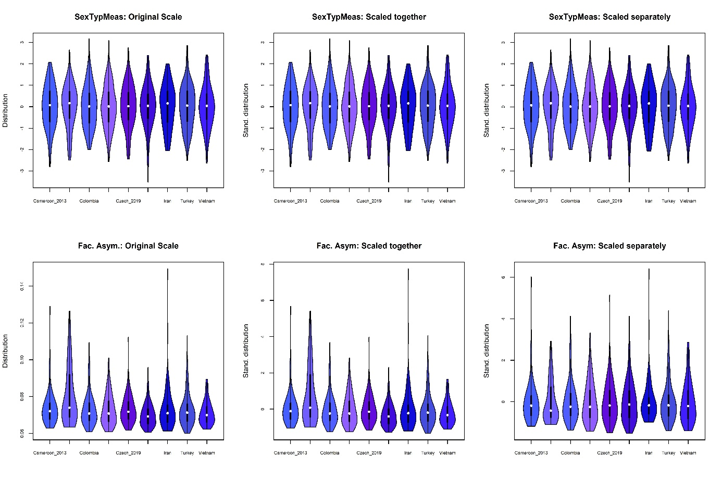

**Figure S10**. Measured facial shape sextypicality (top), facial asymmetry (bottom). Both sexes.

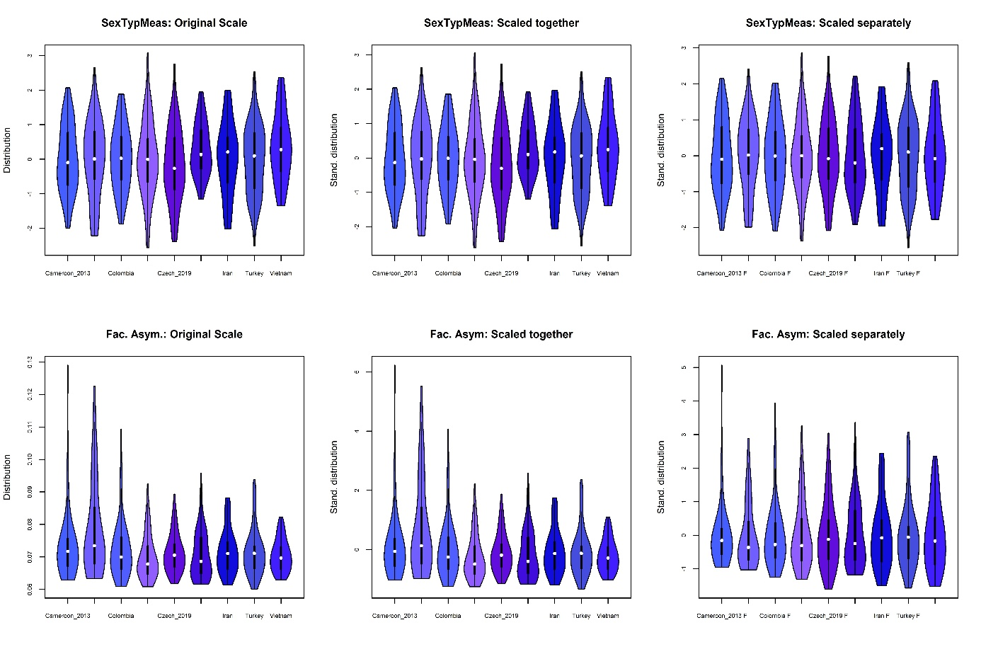

**Figure S11**. Measured facial shape sextypicality (top), facial asymmetry (bottom). Women.

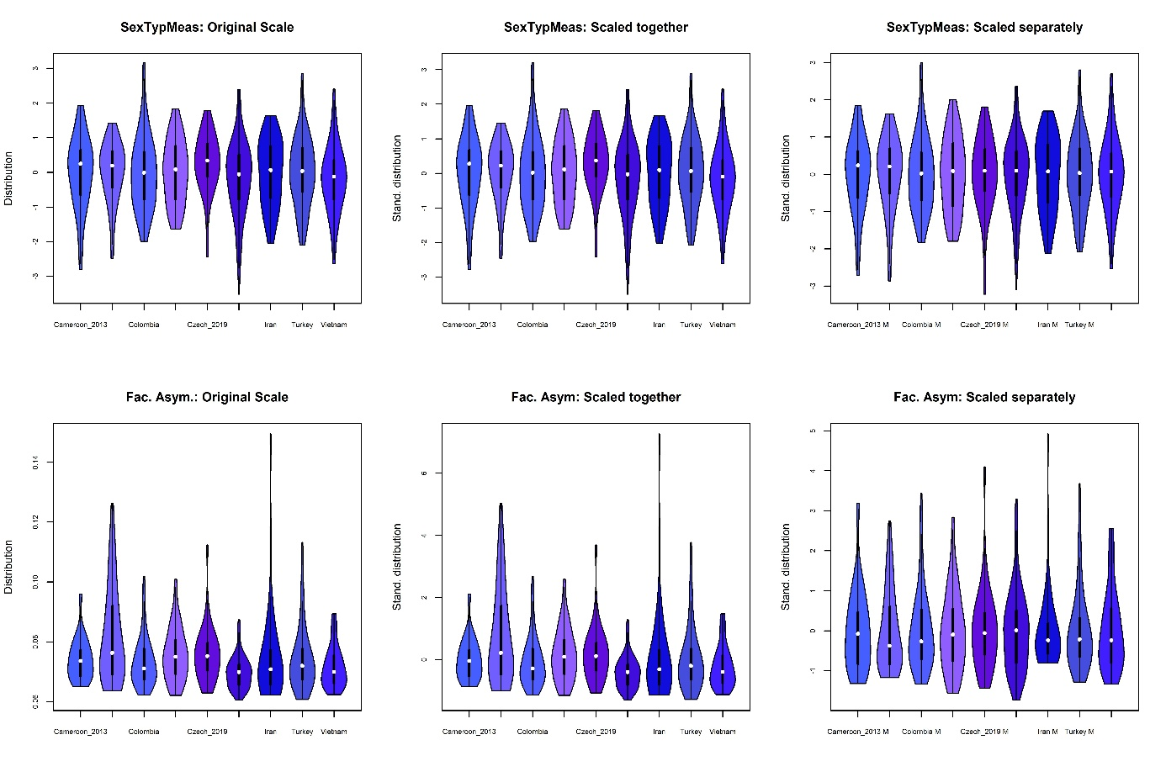

**Figure S12**. Measured facial shape sextypicality (top), facial asymmetry (bottom). Please note that the measured facial shape sextypicality is already scaled.

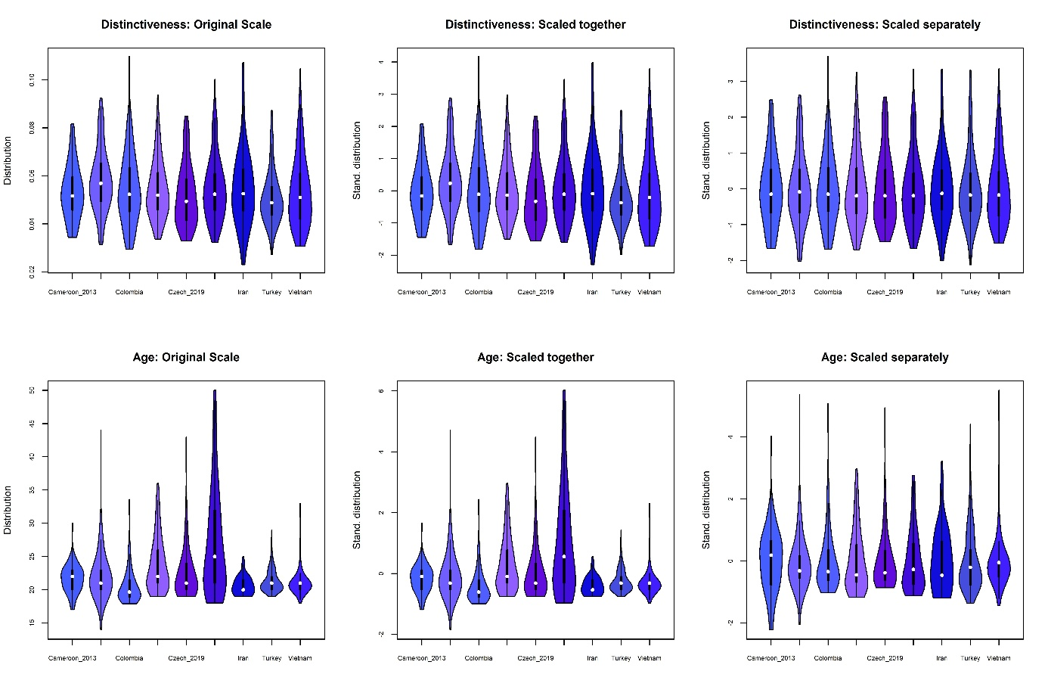

**Figure S13**. Distinctiveness of facial shape (top), Age (bottom). Both sexes.

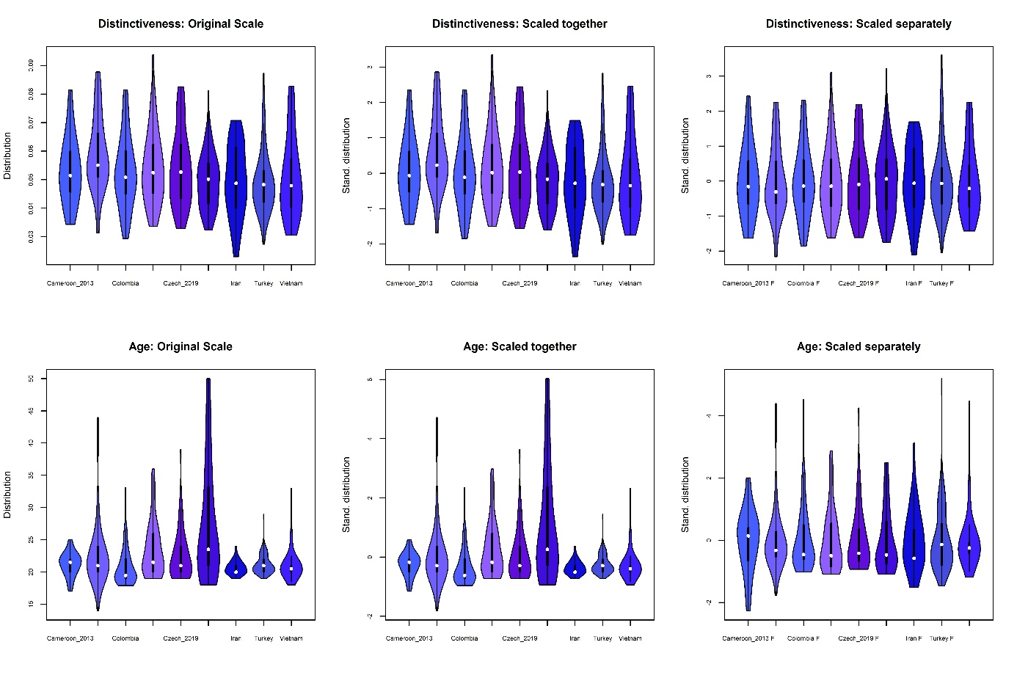

**Figure S14**. Distinctiveness (top), Age (bottom). Women.

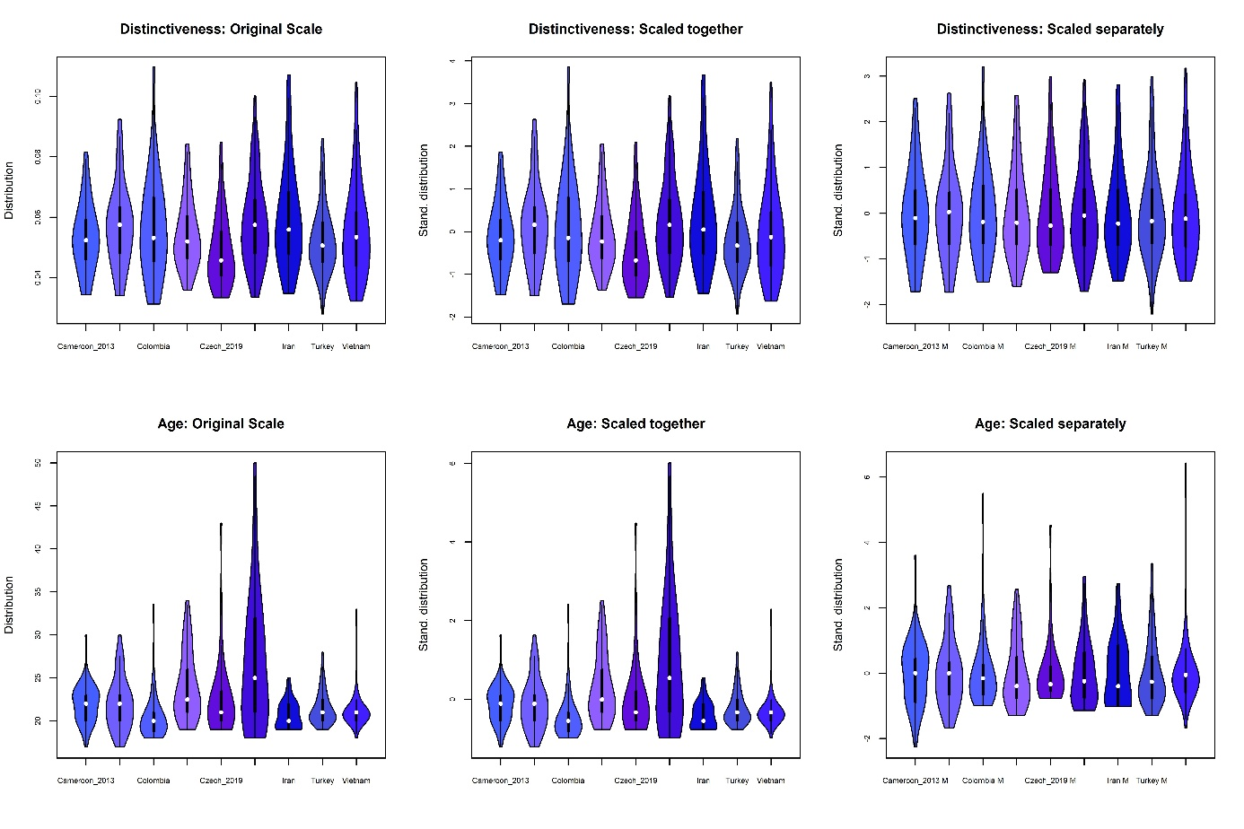

**Figure S15**. Distinctiveness (top), Age (bottom). Men.

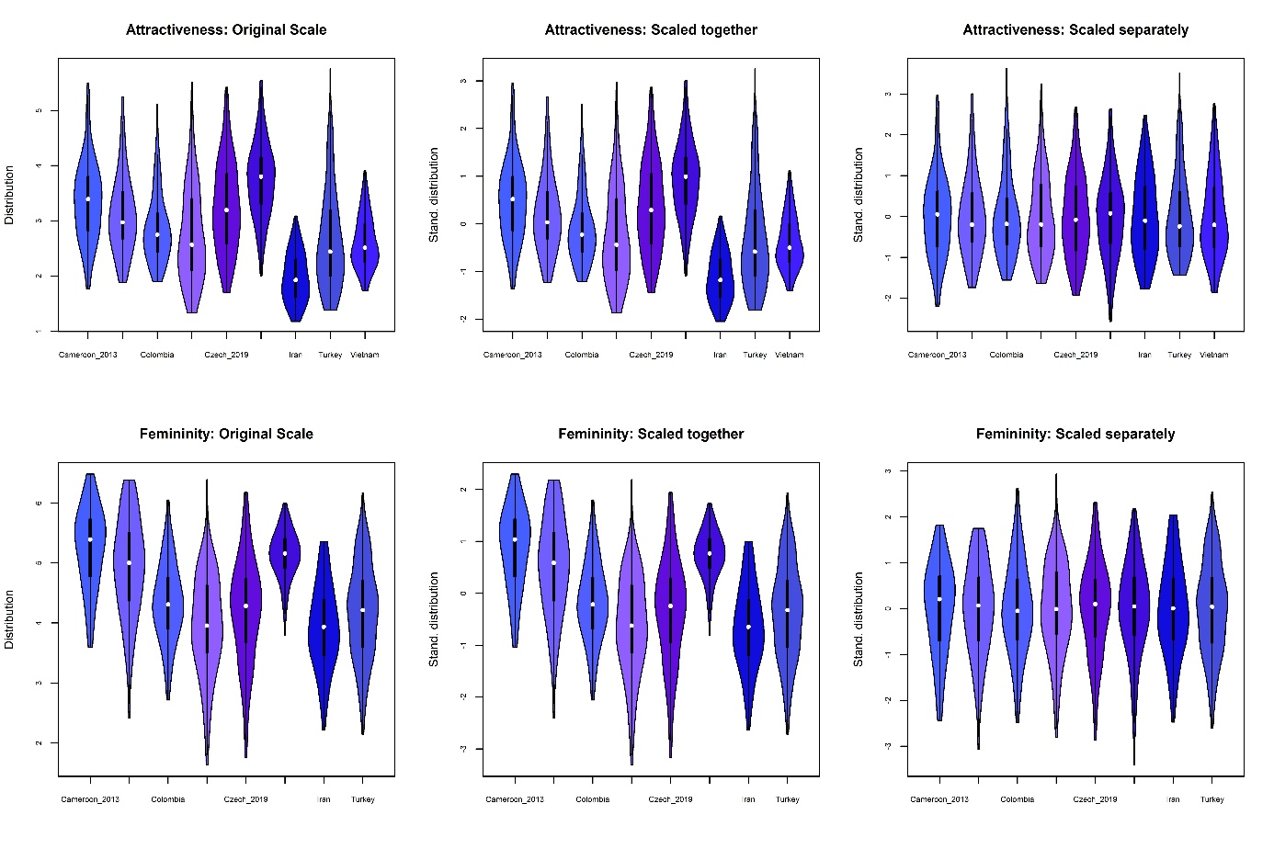

**Figure S16**. Perceived attractiveness (top), perceived sextypicality (bottom). Both sexes.

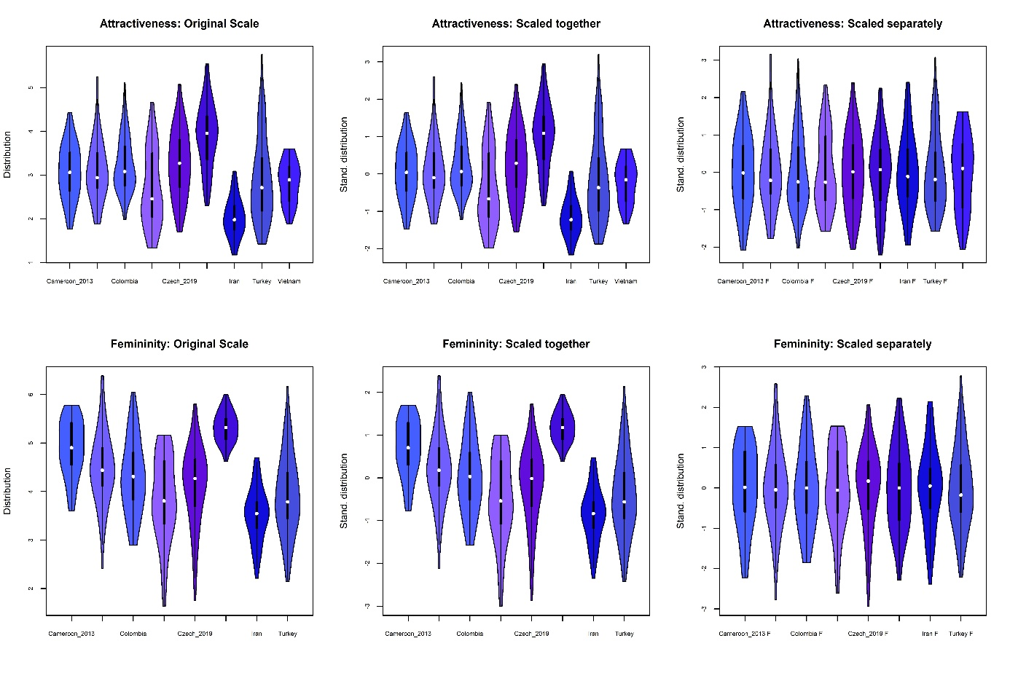

**Figure S17**. Perceived attractiveness (top), perceived femininity (bottom). Women.

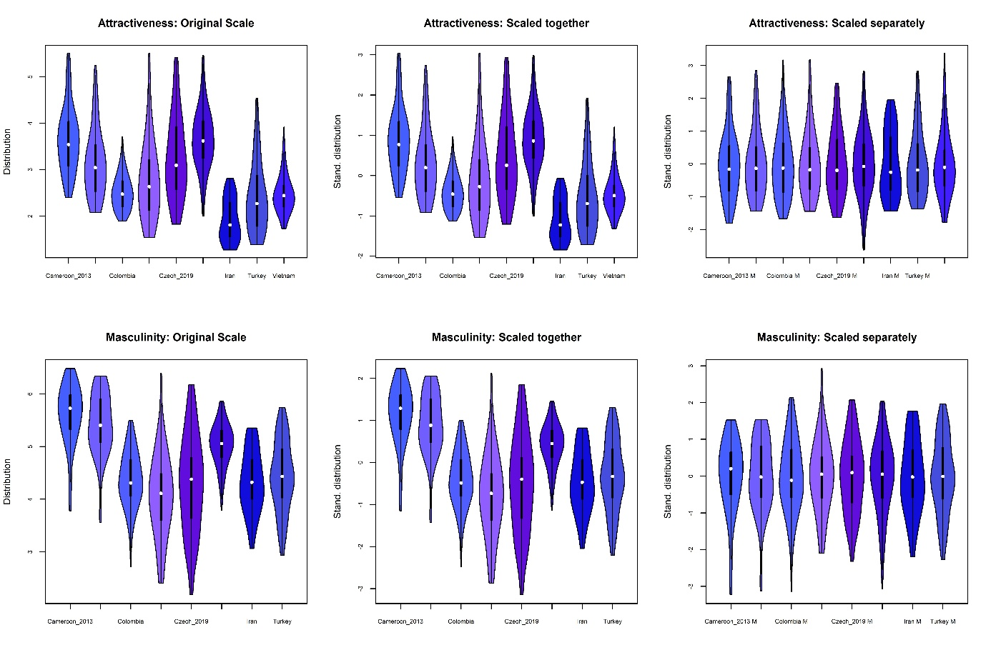

**Figure S18**. Perceived attractiveness (top), perceived masculinity (bottom). Men.

Table S1 [next page] describes the raters’ samples descriptive statistics.

|  |  |  |  |  |  |  |  |  |  |
| --- | --- | --- | --- | --- | --- | --- | --- | --- | --- |
| Table S1. Selected descriptive statistics of the stimuli sample (upper panel) and camera settings (lower panel) | | | | | | | | | |
| Dataset | **Size* (M/F)** | **Researchers** | Age (M/F)  [yrs-1] | PIT L* [Lightness] (M/F) | PIT a* [yellowness] (M/F) | | PIT b* [redness] (M/F) | Attractiveness (M/F) | Perc (M/F) Sextypicality |
| Cameroon 2013 | 49/50 | KK, RMA | 22.00 ± 2.24 / 21.24 ± 1.89 | 41.9 ± 6.86 / 43.82 ± 6.75 | 10.2 ± 1.90 / 8.05 ± 1.98 | | 13.63 ± 2.33 / 12.44 ± 2.50 | 3.65 ± 0.70 / 3.07 ± 0.63 | 5.61 ± 0.57 / 4.89 ± 0.59 |
| Cameroon 2016 | 49/49 | KK, RMA, ŠP | 22.00 ± 3.00 / 22.59 ± 4.92 | 58.78 ± 5.33 / 60.41 ± 4.58 | 8.44 ± 2.28 / 6.35 ± 2.29 | | 20.02 ± 3.42 / 17.36 ± 3.08 | 3.14 ± 0.74 / 3.09 ± 0.69 | 5.42 ± 0.60 / 4.47 ± 0.75 |
| Colombia | 72/66 | JDL | 20.38 ± 2.42 / 20.71 ± 2.77 | 51.42 ± 5.07 / 59.38 ± 5.50 | 4.33 ± 2.51 / 2.27 ± 1.77 | | 9.62 ± 2.57 / 7.94 ± 3.24 | 2.52 ± 0.38 / 3.24 ± 0.63 | 4.37 ± 0.53 / 4.31 ± 0.77 |
| Czech Rep. 2016 | 50/50 | KK, OP, ŠP | 24.04 ± 3.92 / 23.64 ± 4.33 | 66.44 ± 4.09 / 63.47 ± 2.63 | 6.35 ± 2.23 / 5.94 ± 1.04 | | 4.94 ± 1.98 / 2.72 ± 1.54 | 2.78 ± 0.87 / 2.68 ± 0.86 | 4.07 ± 0.80 / 3.85 ± 0.86 |
| Czech Rep. 2019 | 39/56 | OP, ŠP, VF | 22.54 ± 4.55 / 22.61 ± 3.89 | 55.1 ± 3.28 / 54.29 ± 3.89 | 6.75 ± 1.65/ 5.4 ± 1.18 | | 6.31 ± 1.77 / 3.77 ± 1.74 | 3.26 ± 0.89 / 3.26 ± 0.76 | 4.3 ± 0.91 / 4.13 ± 0.82 |
| India (CFD) | 89/52 | Ma et al. (2021) | 26.96 ± 7.86 / 27.73 ± 9.01 | 61.21 ± 5.69 / 64.16 ± 4.92 | 3.83 ± 3.17 / 0.57 ± 3.51 | | 6.96 ± 5.12 / 2.18 ± 4.08 | 3.66 ± 0.64 / 3.9 ± 0.73 | 5.03 ± 0.41 / 5.32 ± 0.31 |
| Iran | 44/43 | FP | 20.64 ± 1.60 / 20.63 ± 1.09 | 56.3 ± 5.05 / 60.77 ± 4.65 | 3.92 ± 2.19 / 2.12 ± 1.34 | | 5.1 ± 3.12 / 3.14 ± 2.38 | 1.92 ± 0.46 / 2.03 ± 0.44 | 4.34 ± 0.58 / 3.52 ± 0.55 |
| Turkey (BFD) | 91/93 | SAS | 21.52 ± 1.95 / 21.2 ± 1.51 | 74.02 ± 3.66 / 73.64 ± 3.34 | 6.51 ± 2.17 / 4.53 ± 1.80 | | 4.3 ± 2.50 / 2.12 ± 1.98 | 2.41 ± 0.76 / 2.89 ± 0.94 | 4.44 ± 0.67 / 3.93 ± 0.81 |
| Vietnam | 59/32 | OP | 21.1 ± 1.86 / 21.16 ± 2.68 | 69.81 ± 3.37 / 68.11 ± 3.63 | 3.24 ± 2.27 / 2.57 ± 1.94 | | 3.85 ± 2.13 / 3.33 ± 3.45 | 2.48 ± 0.43 / 2.84 ± 0.47 | NA ± NA / NA ± NA |
| *This is the final size of the samples after excluding stimuli with missing data (typically age).  **What was actually collected were not ‘sex-typicality’ ratings but ratings of masculinity (men) or femininity (women); see Fiala et al. (2022).  PIT = peri-iridal tissues. The asterisks nexto L*, a* and b* are not a reference to a footnote. It is the way CIELab colour channels are marked (Hunter, 1948; ). | | | | | | | | | |
| Dataset | **City** | **Year** | **Neutral clothes/ Colour checker** | **Camera** | **Lens** | | **Focal length [mm]\*** | **ISO** | **Aperture** |
| Cameroon 2013 | Buea | 2013 | No / Yes | Nikon D90 | NA | | 50 | 100 | 8.00 |
| Cameroon 2016 | Buea | 2016 | Yes / Yes | Nikon D90 | NA | | 50 | 100 | 8.00 |
| Colombia | Bogotá | 2015, 2016 | No / NA | Nikon D3200 | VR DX Zoom Lens (55-200mm) | | 55 | 400 | 4.50 |
| Czech Rep. 2016 | Prague | 2016 | Yes / Yes | Canon EOS 6D | EX SIGMA 1.4f | | 85 | 200 | 5.00 |
| Czech Rep. 2019 | Prague | 2019 | Yes / Yes | Canon EOS 6D | EX SIGMA 1.4f | | 85 | 100 | NA |
| India (CFD) | Delhi | 2019 | Yes / NA | Nikon D90 | | AF Nikkor 50mm | 50 | 200 | 3.2 |
| Iran | Shiraz | 2009 | No** / No | Canon EOS 350D | Canon (18-55 mm) | | 33 | 400 | NA |
| Turkey (BFD) | Istanbul | 2017 | No / No | Nikon D90 | Nikkor 18-105mm | | 105 | Variable | Variable |
| Vietnam | Hanoi | 2018 | Yes / NA | Canon 60D | Canon RF 50mm STM | | 55 | 100 | 8.00 |
| *Different focal lengths may result in the same perspective distortion given the image sensor format.  **But consider that all women in the sample wore black clothes. | | | | | | | | | |

|  |  |  |  |  |  |  |
| --- | --- | --- | --- | --- | --- | --- |
| **Table S2**. Descriptive statistics of the raters' samples | | | | | | |
| Sample | Sex of the stimuli | Rated Trait | No Raters | Mean Age | SD Age | Inter-rater agreement  (3,k)*** |
| Cameroon 2013 | Women | Attractiveness | 34 | 22.21 | 3.14 | 0.91 |
|  |  | Femininity | 77 | 24 | 4.123 | 0.91 |
|  | Men | Attractiveness | 28 | 22.11 | 3.89 | 0.92 |
|  |  | Masculinity | 77 | 24 | 4.123 | 0.95 |
| Cameroon 2016 | Women | Attractiveness | 49 | 22.96 | 3.23 | 0.96 |
|  |  | Femininity | 94 | 22.99 | 3.00 | 0.97 |
|  | Men | Attractiveness | 51 | 23.37 | 4.25 | 0.96 |
|  |  | Masculinity | 94 | 21.99 | 3.00 | 0.96 |
| Colombia | Women | Attractiveness | 432 | 20.71 | 2.77 | 0.99 (1,k) |
|  |  | Femininity | 432 | 20.71 | 2.77 | 0.99 (1,k) |
|  | Men | Attractiveness | 565 | 21.85 | 4.81 | 0.98 (1,k) |
|  |  | Masculinity | 565 | 21.85 | 4.81 | 0.98 (1,k) |
| Czechia 2016 | Women | Attractiveness | 33 | 28.18 | 4.21 | 0.99 |
|  |  | Femininity | 44 | 30 | 9.683 | 0.97 |
|  | Men | Attractiveness | 89 | 27.56 | 4.23 | 0.99 |
|  |  | Masculinity | 231 | 32.039 | 7.595 | 0.99 |
| Czechia 2019 | Women | Attractiveness | 35 | 31.89 | 6.80 | 0.95 |
|  |  | Femininity | 60 | 34.3 | 9.206 | 0.97 |
|  | Men | Attractiveness | 76 | 32.43 | 9.61 | 0.97 |
|  |  | Masculinity | 63 | 34.079 | 8.977 | 0.97 |
| India | Women | Attractiveness | 33.8* | 33.51 | 8.48 | NA** |
|  |  | Femininity | 33.8* | 33.51 | 8.48 | NA |
|  | Men | Attractiveness | 19.5* | 33.51 | 8.48 | NA |
|  |  | Masculinity | 19.5* | 33.51 | 8.48 | NA |
| Iran | Women | Attractiveness | 46 | 37.3 | 12.29 | 0.93 |
|  |  | Femininity | 33 | 27.73 | 3.77 | 0.92 |
|  | Men | Attractiveness | 41 | 34.88 | 9.91 | 0.9 |
|  |  | Masculinity | 31 | 29.35 | 4.54 | 0.93 |
| Turkey | Women | Attractiveness | 1207 | 22.09 | 3.66 | 0.96 (1,k) |
|  |  | Femininity | 1207 | 22.09 | 3.66 | 0.95 (1,k) |
|  | Men | Attractiveness | 1207 | 22.09 | 3.66 | 0.95 (1,k) |
|  |  | Masculinity | 1207 | 22.09 | 3.66 | 0.94 (1,k) |
| Vietnam | Women | Attractiveness | 86 | 22.2 | 3.76 | 0.96 |
|  |  | Femininity | NA | NA | NA | NA |
|  | Men | Attractiveness | 124 | 22.96 | 4.26 | 0.98 |
|  |  | Masculinity | NA | NA | NA | NA |
| *Average No. Of raters per face (878 [238 Females] fulfilled the authors criteria (Ma et al., 2021) to be included.  **When there is NA, we do not have access to the original individual ratings.  ***If the format of the data does not allow using ICC(3,k), ICC(1,k) is used. | | | | | | |

## Section 2: Model layout

Terms printed in **bold** are fitted as varying and intercorrelated. Terms followed by [sex] were estimated separately for women and men. Women were coded as “1” and men were assigned “2”, and every sample, too, has its own integer instead of “Grp” (1-9 [1-8] for attractiveness [sextypicality]). The arithmetic operation in the equation introduces series of 24 integers – for every predictor and sex. Together, this varying multi-level structure allows for each effect to be estimated in every sample and sex. Due to *frozen accident* (models designed before writing the manuscript) we use the terms “L/a/b_sclera” to estimate effects of PIT (peri-iridal tissues).

m1_attr <- ulam(

alist(

Attractiveness ~ normal(mu, sigma),

mu <- mu1 + mu2,

mu1 <- A[Sex] +

**betas[Grp, 1 + (Sex - 1)*12]** + # Intercept (fixed, then per-culture, per-Sex)

BSexTyp[Sex]*MeasSext + **betas[Grp, 2 + (Sex - 1)*12]*MeasSext** + # Sex typicality

BAsym[Sex]*Asym + **betas[Grp, 3 + (Sex - 1)*12]*Asym** + # Asymmetry

BDIST [Sex]*DIST + **betas[Grp, 4 + (Sex - 1)*12]*DIST** + # Distinctiveness

BAge[Sex]*Age + **betas[Grp, 5 + (Sex - 1)*12]*Age** + # Age

B_L_Skin[Sex]\***L_skin + betas[Grp, 6 + (Sex - 1)*12]*L_skin**, # Skin lightness

mu2 <- B_L_iris[Sex]*L_iris + **betas[Grp, 7 + (Sex - 1)*12]*L_iris** + # Iris lightness

B_a_iris[Sex]*a_iris + **betas[Grp, 8 + (Sex - 1)*12]*a_iris** + # Iris redness

B_b_iris[Sex]*b_iris + **betas[Grp, 9 + (Sex - 1)*12]*b_iris** + # Iris yellowness

B_L_sclera[Sex]*L_sclera + **betas[Grp, 10 + (Sex - 1)*12]*L_sclera** + # PIT lightness

B_a_sclera[Sex]*a_sclera + **betas[Grp, 11 + (Sex - 1)*12]*a_sclera** + # PIT redness

B_b_sclera[Sex]*b_sclera + **betas[Grp, 12 + (Sex - 1)*12]*b_sclera**, # PIT yellowness

# Non-centered parameterization for betas

transpars> matrix[Grp, 24]:betas <- compose_noncentered(sigma_group, L_Rho_group, z_group),

matrix[24, Grp]:z_group ~ normal(0, 1),

# Hyperpriors for the group-level effects

vector[24]:sigma_group ~ dexp(1),

cholesky_factor_corr[24]:L_Rho_group ~ lkj_corr_cholesky(2),

A[Sex] ~ normal(0, 0.2),

vector[2]:BSexTyp ~ normal(0, 0.5),

vector[2]:BDIST ~ normal(0, 0.5),

vector[2]:BAsym ~ normal(0,0.5),

vector[2]:BAge ~ normal(0, 0.5),

vector[2]:B_L_Skin ~ normal(0, 0.5),

vector[2]:B_L_iris ~ normal(0, 0.5),

vector[2]:B_a_iris ~ normal(0, 0.5),

vector[2]:B_b_iris ~ normal(0, 0.5),

vector[2]:B_L_sclera ~ normal(0, 0.5),

vector[2]:B_a_sclera ~ normal(0, 0.5),

vector[2]:B_b_sclera ~ normal(0, 0.5),

sigma ~ dexp(1),

gq> matrix[24, 24]:Rho_group <<- Chol_to_Corr(L_Rho_group)

), data = data_Attr2, chains = 4, cores = 4, log_lik = T, iter = 2500, control = list(max_treedepth = 18, adapt_delta = 0.99)

)

## Section 3. “Standardised separately” & alternative subsets

### 3.1. Standardised separately, full analysis.

Alternative setup: data are standardised separately in each sample. This way the information on relative variance between different samples is not preserved. Absolute size of the estimated associations should better represent how important is the available variance for the within-population raters.

**Figure S19**. Estimated slopes of the associations between perceived attractiveness in women (left half), and men (right half) and iris and scleral colour, L*, a*, and b* (upper, middle, lower panel). All the variables were standardised separately (standardisation within each sample). See Figures 3-4 in the main article for a comparison. The associations mostly follow the same pattern but are weaker. This is a consequence of standardising separately: different within-culture ranges of iris and peri-iridal tissues’ L*a*b*, when weighted equally, lowers the strength of the association. The global effect is not allowed to “learn more” from the more pronounced effect in more variable populations.



**Figure S20**. Perceived sextypicality, all variables were standardised across cultures. The layout is the same as in Figure S19.

### 3.2. Standardised together, analysis without Iranian sample.

The Iranian women were photographed and rated when wearing hijab, a piece of clothing that covers the hair and may cover the edge of the mandible. This may impair the shape analyses, as the semilandmarks denoting this edge are laid less precisely. If the original analysis was affected by incorrectly denoted faces in the Iranian sample, the results would change. Unchanged results would show the opposite. The reader can also check that the results do not change when one sample is left out.

**Figure S21**. Perceived attractiveness in women (left half), and men (right half) of the Figure, predicted by iris and scleral colour (left/right – in each sex) L*, a*, and b* (upper, middle, lower panel). All the variables were standardised together (standardisation across all the samples). Iranian samples were excluded from the analysis.

**Figure S22**. Perceived sextypicality in women (left half), and men (right half) of the Figure, predicted by iris and scleral colour (left/right – in each sex) L*, a*, and b* (upper, middle, lower panel). All the variables were standardised together (standardisation across all the samples). Iranian samples were excluded from the analysis.

### 3.3. Standardised together, analysis without considering skin L* (lightness) as a predictor.

Lightness (L*) of the skin is an important predictor of facial characteristics, at least in some cultures (Fiala et al., 2021, Pokorný et al. 2024). Including or excluding this measure may affect the results. In case the effects were substantially altered or even reverted (e.g., lighter PIT was associated with higher, not lower, attractiveness and sextypicality), it would suggest that skin tone and eye morphology are intrinsically related. Then, it would not have sense to speak about “effects of PIT” as a stand-alone phenomenon.

**Figure S23**. Perceived attractiveness in women (left half), and men (right half) of the Figure, predicted by iris and scleral colour (left/right – in each sex) L*, a*, and b* (upper, middle, lower panel). All the variables were standardised together (standardisation across all the samples). A version of the model without skin L*.



**Figure S24**. Perceived sextypicality in women (left half), and men (right half) of the Figure, predicted by iris and scleral colour (left/right – in each sex) L*, a*, and b* (upper, middle, lower panel). All the variables were standardised together (standardisation across all the samples). A version of the model without skin L*.

While some of the associations become less pronounced or less precisely estimated, the overall pattern of the associations is preserved. Including facial skin L* in the analysis is important; however, the effect of eye morphology is present even when skin lightness is not in the analysis. The two aspects of facial morphology are intrinsically related and including skin L* in the analysis allows the effects of PIT L* to “stand out”; however, the effect of eye morphology is robust.

## Section 4. Bayesian path analyses

### 4.1. Women:

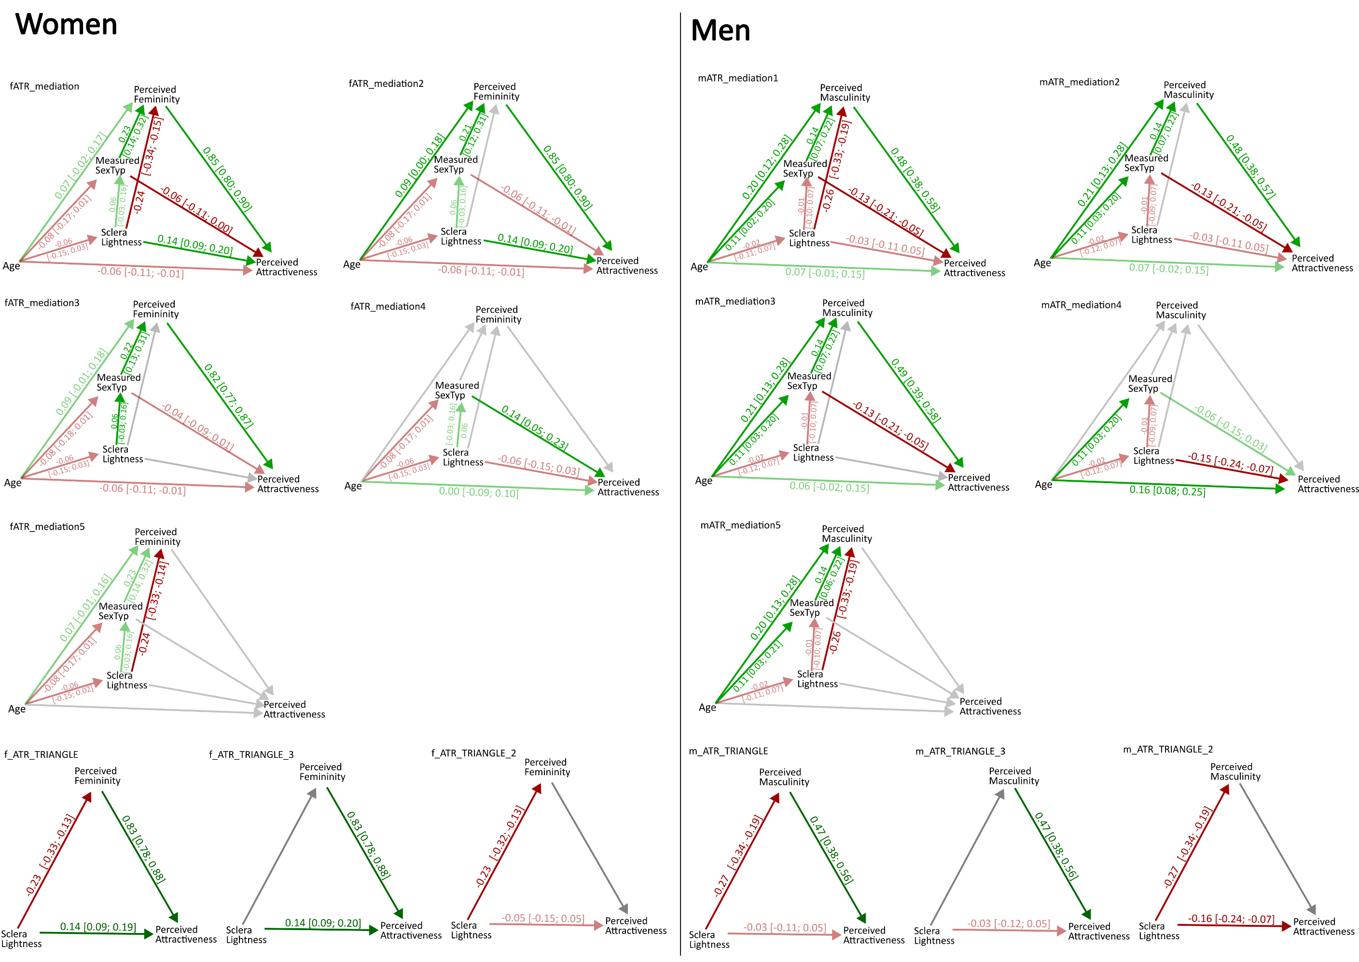

**Figure S25**. Bayesian path analyses. Women. Extended version of Figure 4 from the manuscript. Titles of the models correspond to name of the models’ objects in the script and are unimportant. Follow the layout instead. Arrows that are printed in grey were not fitted in the given analysis.

### 4.2. Men

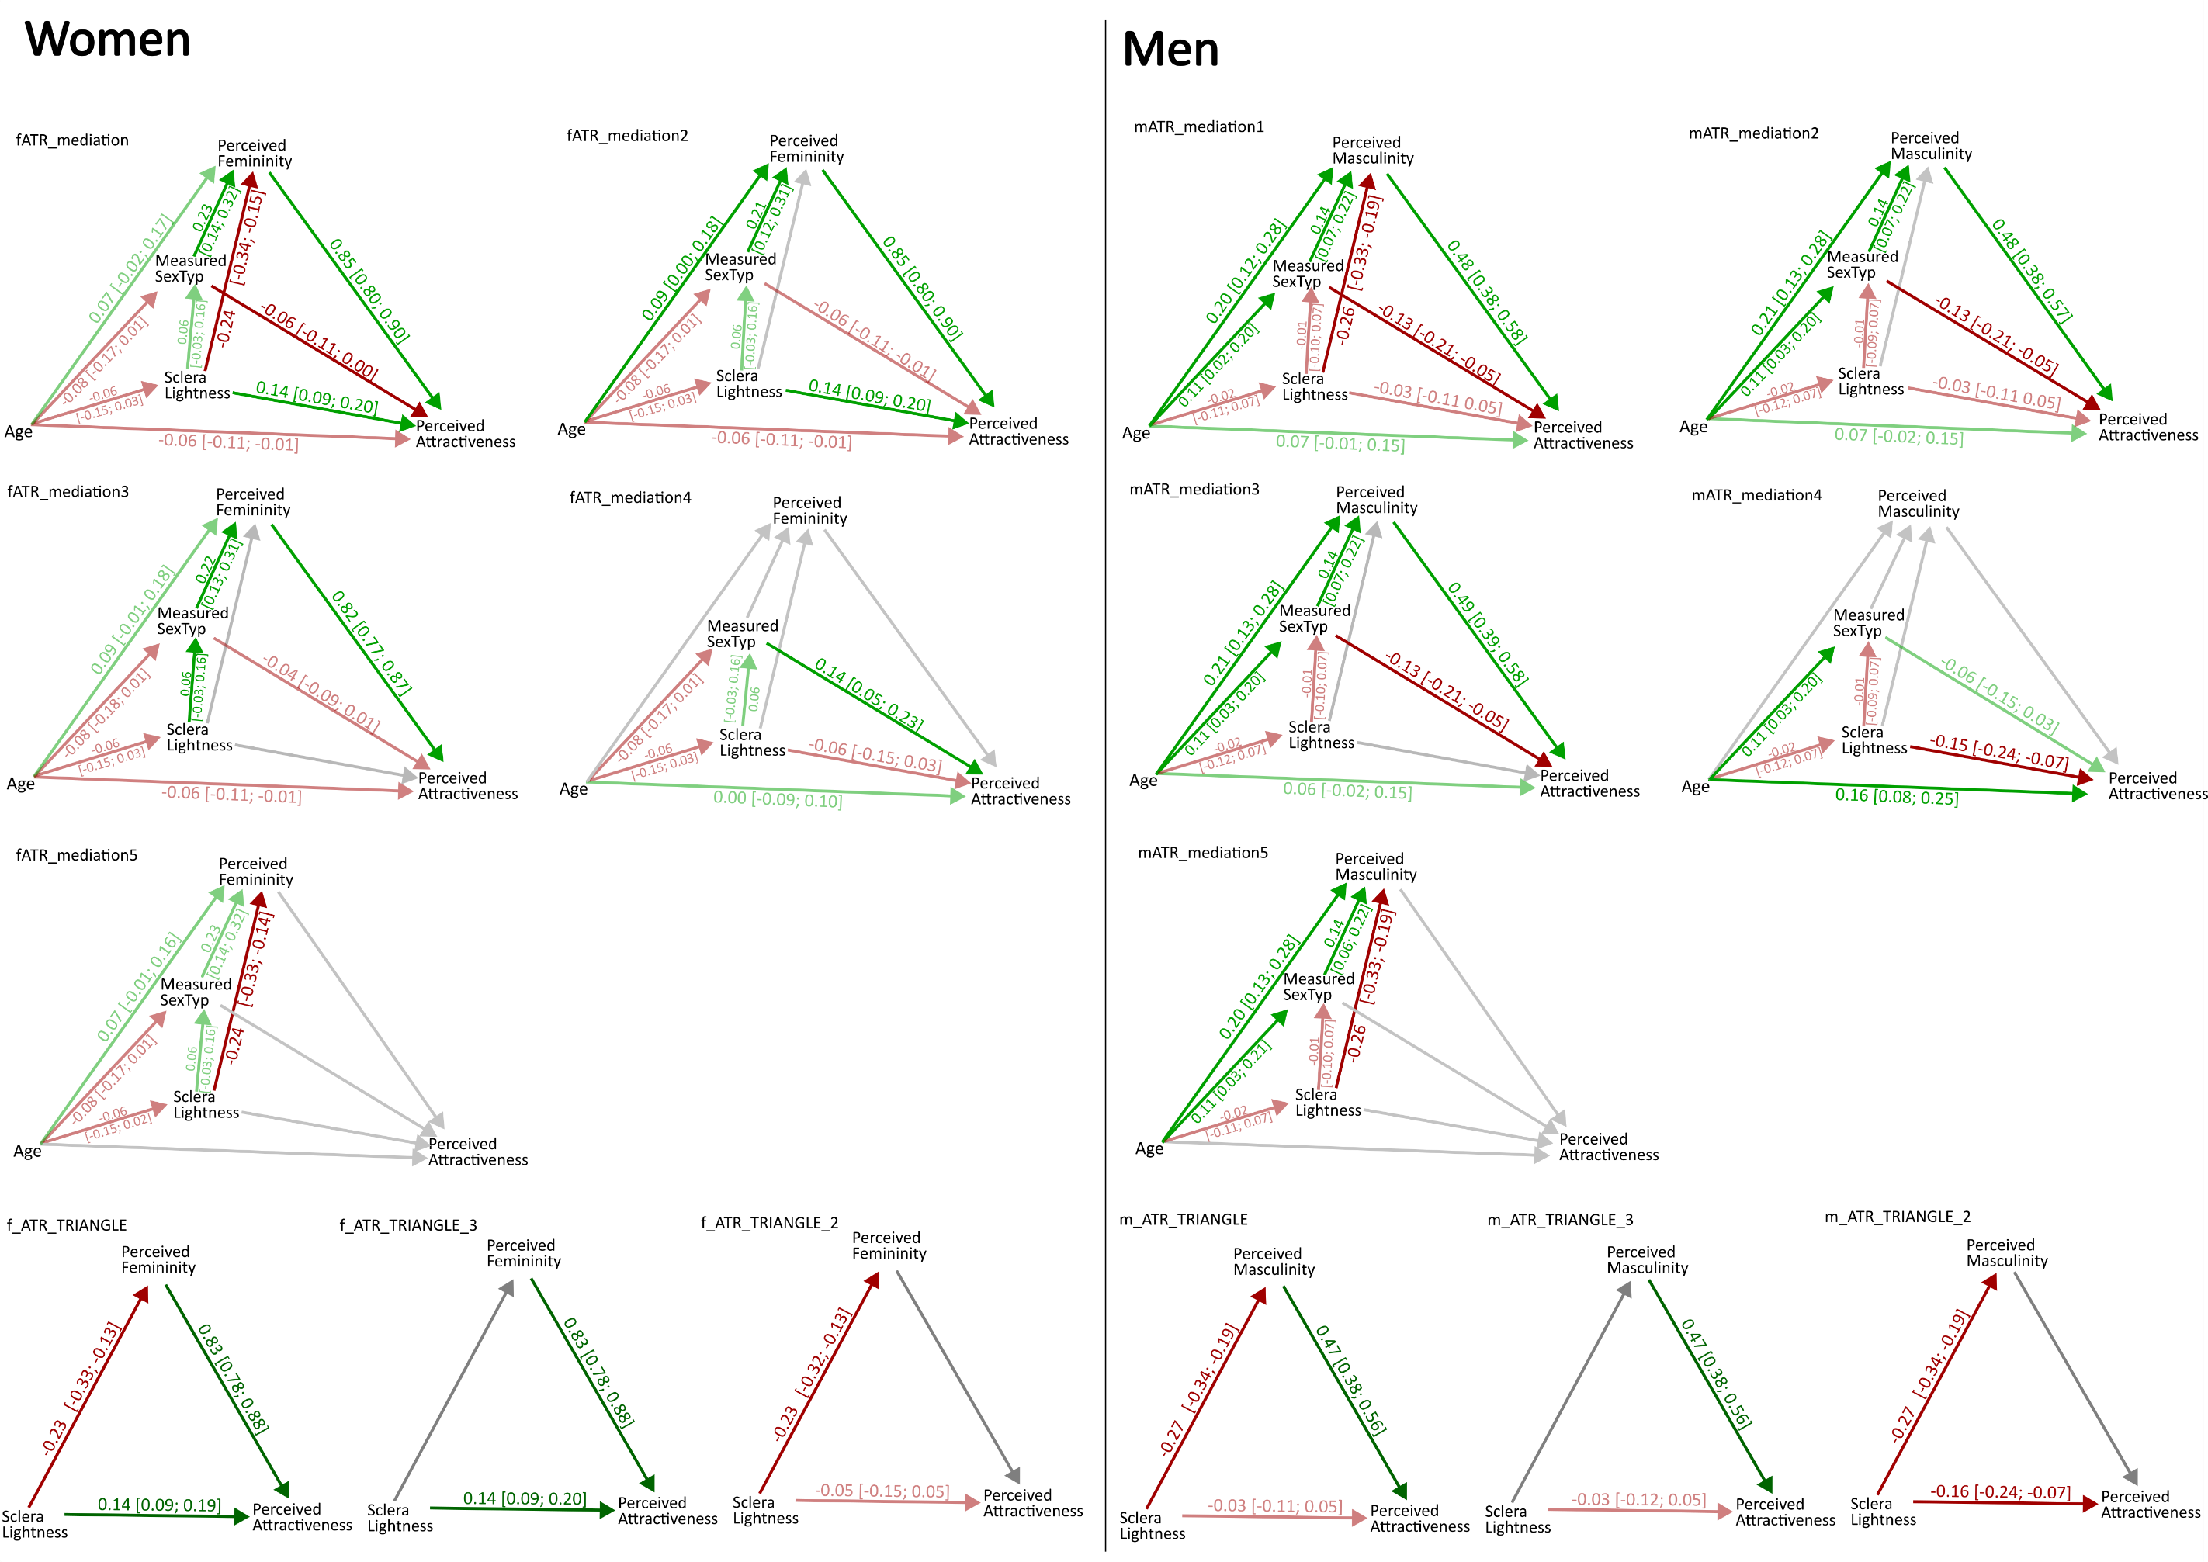

**Figure S26**. Bayesian path analyses. Men. Extended version of Figure 4 from the article.

### 4.3. Path Analyses per culture (F = female sample, M = male sample):

In what follows, the path analyses are fitted separately in each sample. Grey arrows were omitted in the analyses.

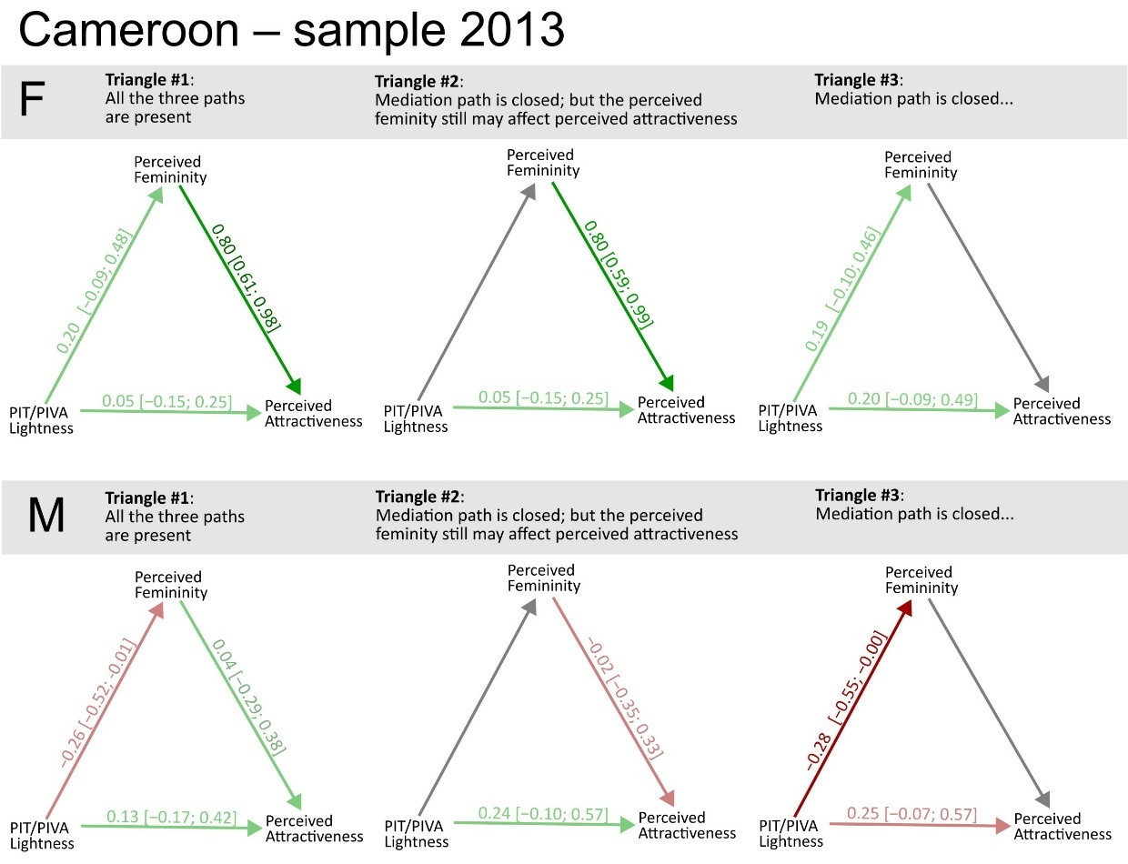

**Figure S27**. Path analyses – Cameroon, 2013 sample. Peri-iridal T. ~ peri-iridal tissues.

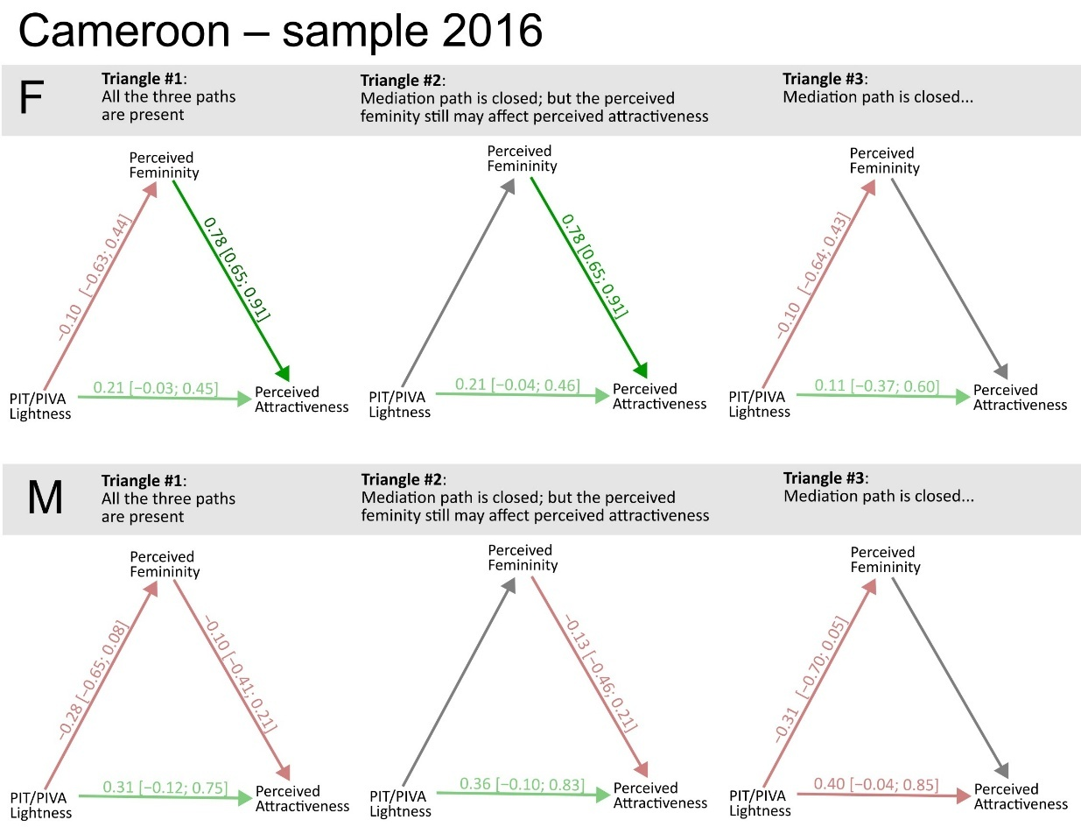

**Figure S28**. Path analyses – Cameroon, 2016 sample

Obsah obrázku text, diagram, řada/pruh, Vykreslený graf

Obsah vygenerovaný umělou inteligencí může být nesprávný.

**Figure S29**. Path analyses – Colombian sample

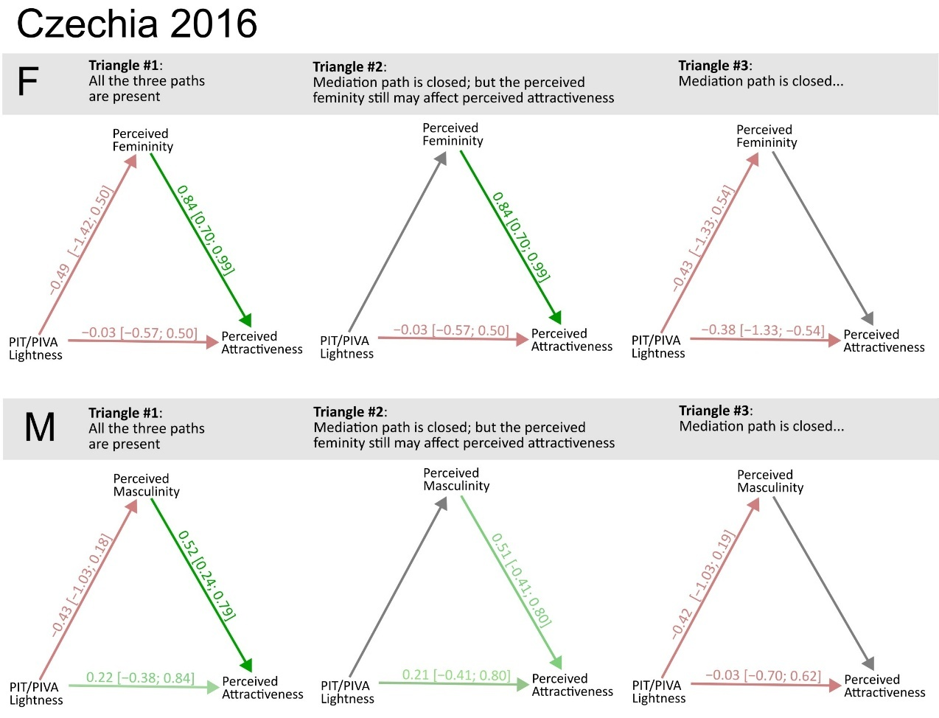

**Figure S30**. Czechia, sample 2016. Please note the massively bevidened credible intervals.

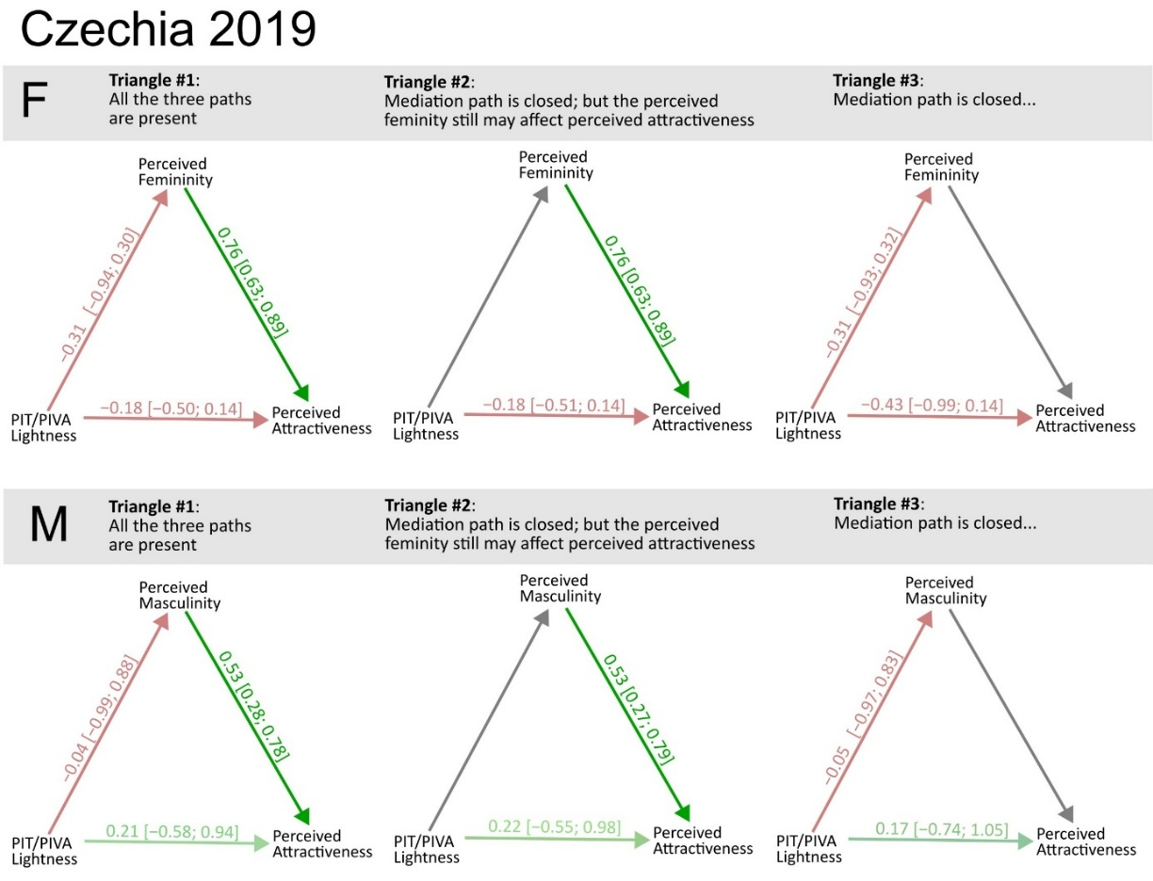

**Figure S31**. Czechia, sample 2019. Please note the massively wide credible intervals when the path between masculinity and attractiveness is closed, suggesting on collinearity.

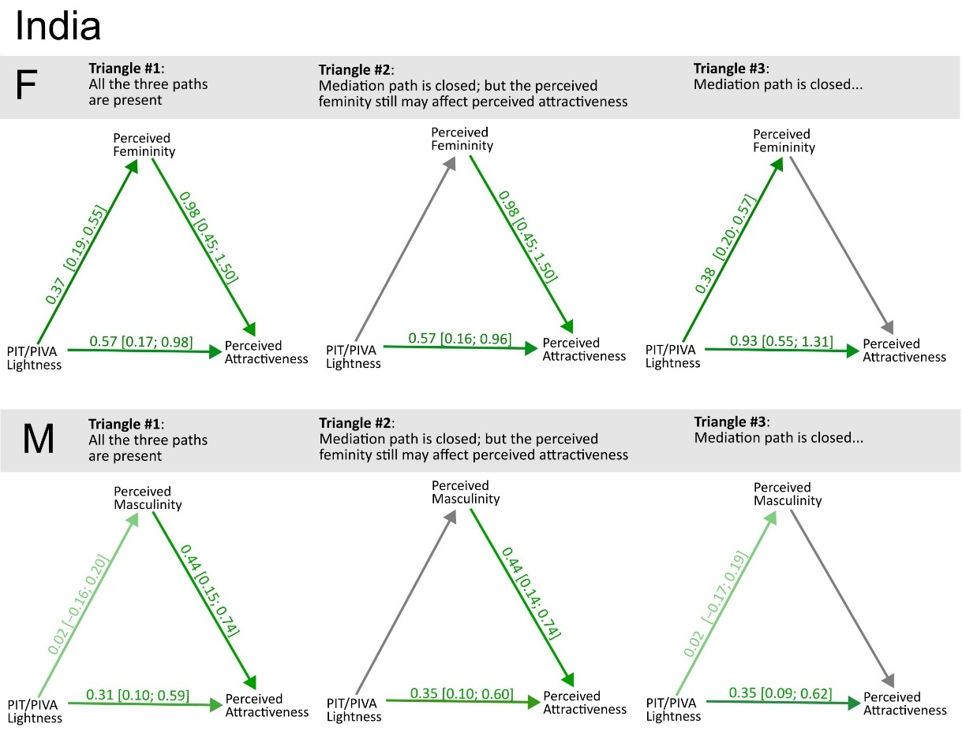

**Figure S32**. India.

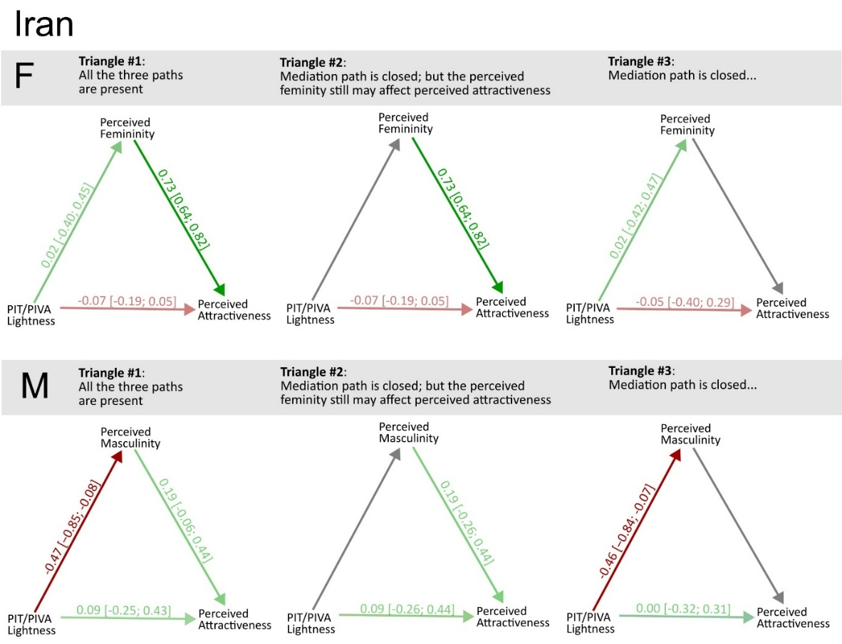

**Figure S33**. Iran.

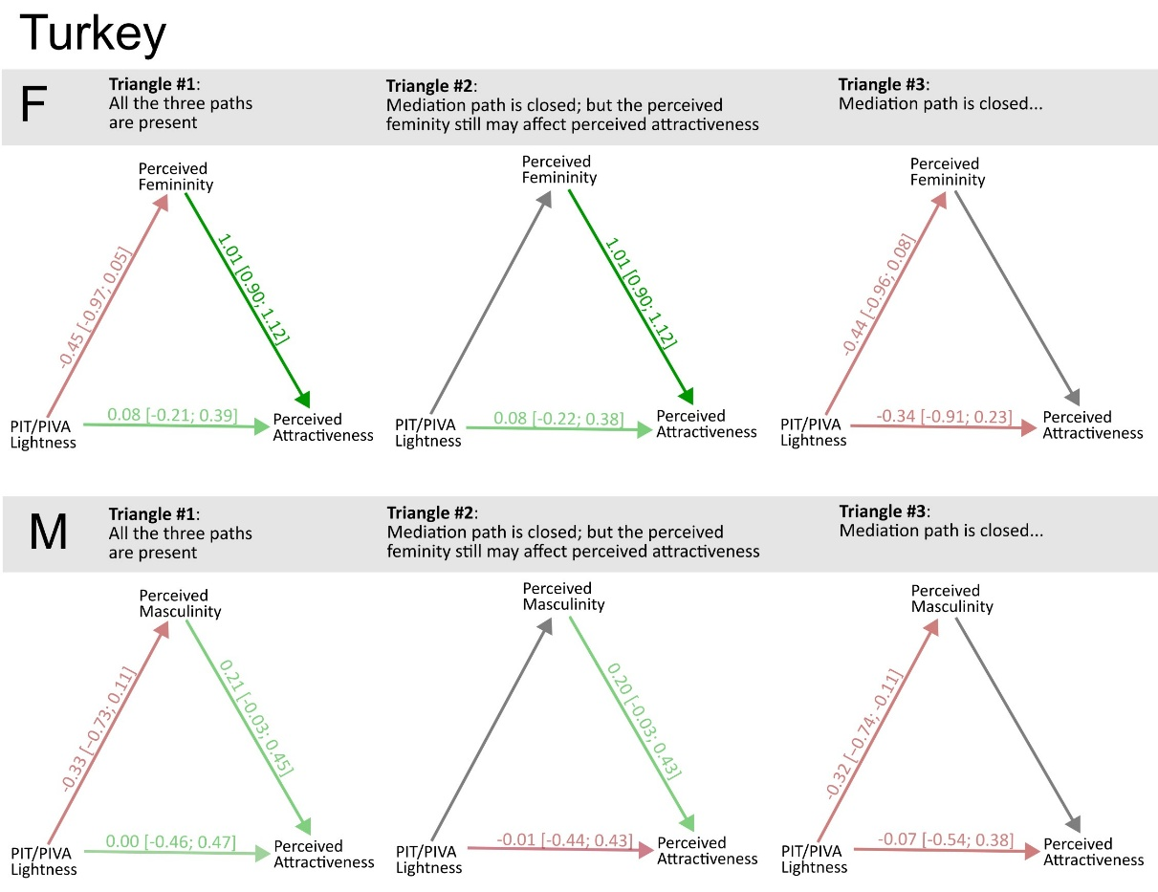

**Figure S34**. Turkey

## Section 5: Models based on individual ratings

In eight of the samples, we got an access to individual rating data. In case of Chicago Face Database – Indian Expansion, the authors responded to our request to get the individual rating data negatively. Currently, they are preparing their own version of the individual rating dataset. We recommend following updates on their webpage (https://www.chicagofaces.org/).

For the subset of eight cultures, we fitted ordered logistic regression models following the structure outlined in the main manuscript. For both attractiveness and sex-typicality, four alternative parameterisations were considered. Model 1 excluded all rater-level varying effects. Model 2 included only a varying intercept for each rater. Models 3 and 4 incorporated varying effects for all predictors at the rater level; while these models are mathematically equivalent, only Model 4 employed a non-centred parameterisation.

Transcription below corresponds to models with either attractiveness or sextypicality as the dependent variable (“rating”):

### 5.1. Model 1 and 2 (changes denoted in the model layout):

m2_attr <- ulam(

alist(

rating ~ ordered_logistic(phi, alpha),

phi <- mu1 + mu2 + mu3

mu1 <- B_sex*sex_c +

betas[Grp, 1 + (Sex - 1)*12] + # Intercept (fixed, then per-culture, per-Sex)

BSexTyp[Sex]*MeasSext + betas[Grp, 2 + (Sex - 1)*12]*MeasSext + # Sex typicality

BAsym[Sex]*Asym + betas[Grp, 3 + (Sex - 1)*12]*Asym + # Asymmetry

BDIST [Sex]*DIST + betas[Grp, 4 + (Sex - 1)*12]*DIST + # Distinctiveness

BAge[Sex]*Age + betas[Grp, 5 + (Sex - 1)*12]*Age + # Age

B_L_Skin[Sex]*L_skin + betas[Grp, 6 + (Sex - 1)*12]*L_skin, # Skin lightness

mu2 <- B_L_iris[Sex]*L_iris + betas[Grp, 7 + (Sex - 1)*12]*L_iris + # Iris lightness

B_a_iris[Sex]*a_iris + betas[Grp, 8 + (Sex - 1)*12]*a_iris + # Iris redness

B_b_iris[Sex]*b_iris + betas[Grp, 9 + (Sex - 1)*12]*b_iris + # Iris yellowness

B_L_sclera[Sex]*L_sclera + betas[Grp, 10 + (Sex - 1)*12]*L_sclera + # Sclera lightness

B_a_sclera[Sex]*a_sclera + betas[Grp, 11 + (Sex - 1)*12]*a_sclera + # Sclera redness

B_b_sclera[Sex]*b_sclera + betas[Grp, 12 + (Sex - 1)*12]*b_sclera, # Sclera yellowness

mu3 <- z_t[tar]*sigma_t + *[Only in Model 2] z_pr[rat]*sigma_r [Only in Model 2]*

# Non-centered parameterization for betas

transpars> matrix[Grp, 24]:betas <- compose_noncentered(sigma_group, L_Rho_group, z_group),

matrix[24, Grp]:z_group ~ normal(0, 1),

# Hyperpriors for the group-level effects

vector[24]:sigma_group ~ dexp(1),

cholesky_factor_corr[24]:L_Rho_group ~ lkj_corr_cholesky(2),

B_sex ~ normal(0, 0.5),

vector[2]:BSexTyp ~ normal(0, 0.5),

vector[2]:BDIST ~ normal(0, 0.5),

vector[2]:BAsym ~ normal(0,0.5),

vector[2]:BAge ~ normal(0, 0.5),

vector[2]:B_L_Skin ~ normal(0, 0.5),

vector[2]:B_L_iris ~ normal(0, 0.5),

vector[2]:B_a_iris ~ normal(0, 0.5),

vector[2]:B_b_iris ~ normal(0, 0.5),

vector[2]:B_L_sclera ~ normal(0, 0.5),

vector[2]:B_a_sclera ~ normal(0, 0.5),

vector[2]:B_b_sclera ~ normal(0, 0.5),

# Level of individual faces:

z_t[tar] ~ normal(0,1),

sigma_t ~ dexp(1),

*[Only in Model 2]*

# level of individual raters (intercept only):

z_pr[rat] ~ normal(0,1),

sigma_r ~ dexp(1),

*[Only in Model 2]*

gq> matrix[24, 24]:Rho_group <<- Chol_to_Corr(L_Rho_group),

alpha ~ normal(0,1.5)

), data=d.list , chains=4 , cores=4, log_lik=TRUE ,iter = 750, warmup=250, sample=T)

### 5.2. Model 3 and 4 (changes denoted in the model layout):

m3_attr <- ulam(

alist(

rating ~ ordered_logistic(phi, alpha),

phi <- mu1 + mu2 + mu3 + mu4, # mu3-4 bude level hodnotitele a ksichta...

mu1 <- B_sex*sex_c +

betas[Grp, 1 + (Sex - 1)*12] + # Intercept (fixed, then per-culture, per-Sex)

BSexTyp[Sex]*MeasSext + betas[Grp, 2 + (Sex - 1)*12]*MeasSext + # Sex typicality

BAsym[Sex]*Asym + betas[Grp, 3 + (Sex - 1)*12]*Asym + # Asymmetry

BDIST [Sex]*DIST + betas[Grp, 4 + (Sex - 1)*12]*DIST + # Distinctiveness

BAge[Sex]*Age + betas[Grp, 5 + (Sex - 1)*12]*Age + # Age

B_L_Skin[Sex]*L_skin + betas[Grp, 6 + (Sex - 1)*12]*L_skin, # Skin lightness

mu2 <- B_L_iris[Sex]*L_iris + betas[Grp, 7 + (Sex - 1)*12]*L_iris + # Iris lightness

B_a_iris[Sex]*a_iris + betas[Grp, 8 + (Sex - 1)*12]*a_iris + # Iris redness

B_b_iris[Sex]*b_iris + betas[Grp, 9 + (Sex - 1)*12]*b_iris + # Iris yellowness

B_L_sclera[Sex]*L_sclera + betas[Grp, 10 + (Sex - 1)*12]*L_sclera + # Sclera lightness

B_a_sclera[Sex]*a_sclera + betas[Grp, 11 + (Sex - 1)*12]*a_sclera + # Sclera redness

B_b_sclera[Sex]*b_sclera + betas[Grp, 12 + (Sex - 1)*12]*b_sclera, # Sclera yellowness

mu3 <- pr[rat,1] + pr[rat,2]*MeasSext + pr[rat,3]*Asym + pr[rat,4]*DIST +

pr[rat,5]*Age + pr[rat,6]*L_skin + pr[rat,7]*L_iris +

pr[rat,8]*a_iris + pr[rat,9]*b_iris + pr[rat,10]*L_sclera +

pr[rat,11]*a_sclera + pr[rat,12]*b_sclera,

mu4 <- z_t[tar]*sigma_t,

# Non-centered parameterization for betas

transpars> matrix[Grp, 24]:betas <- compose_noncentered(sigma_group, L_Rho_group, z_group),

matrix[24, Grp]:z_group ~ normal(0, 1),

# Hyperpriors for the group-level effects

vector[24]:sigma_group ~ dexp(1),

cholesky_factor_corr[24]:L_Rho_group ~ lkj_corr_cholesky(2),

B_sex ~ normal(0, 0.5),

vector[2]:BSexTyp ~ normal(0, 2.5),

vector[2]:BDIST ~ normal(0, 2.5),

vector[2]:BAsym ~ normal(0,2.5),

vector[2]:BAge ~ normal(0, 2.5),

vector[2]:B_L_Skin ~ normal(0, 2.5),

vector[2]:B_L_iris ~ normal(0, 2.5),

vector[2]:B_a_iris ~ normal(0, 2.5),

vector[2]:B_b_iris ~ normal(0, 2.5),

vector[2]:B_L_sclera ~ normal(0, 2.5),

vector[2]:B_a_sclera ~ normal(0, 2.5),

vector[2]:B_b_sclera ~ normal(0, 2.5),

# Level of individual faces:

z_t[tar] ~ normal(0,1),

sigma_t ~ dexp(1),

*[****MODEL 3 only****]*

*# level of individual raters (full-scope):*

*vector[12]:pr[rat] ~ multi_normal(c(0,0,0,0,0,0,0,0,0,0,0,0),Rho_r,sigma_r),*

*sigma_r ~ dexp(1),*

*Rho_r ~ lkj_corr(2),*

*[****MODEL 3 only****]*

*[****MODEL 4 only****]*

*# level of individual raters (full-scope):*

*transpars> matrix[rat,12]:pr <- compose_noncentered(sigma_r, L_Rho_r, z_r), # sorry, rep(0,12) does not work!*

*matrix[12,rat]:z_r ~ normal(0,1),*

*vector[12]:sigma_r ~ dexp(1),*

*cholesky_factor_corr[12]:L_Rho_r ~ lkj_corr_cholesky(2),*

*gq> matrix[12,12]:Rho_r <<- Chol_to_Corr(L_Rho_r),*

*[****MODEL 4 only****]*

gq> matrix[24, 24]:Rho_group <<- Chol_to_Corr(L_Rho_group),

alpha ~ normal(0,1.5)

), data=d.list , chains=4 , cores=4, log_lik=TRUE ,iter = 750, warmup=250, sample=T)

### 5.3 Estimates

Note that the effects reported below are expressed on the ordered-logit scale, corresponding to 1-7 Likert scale.

#### 5.3.1. Attractiveness

WAIC (out of sample predictive accuracy) model comparison reveals that models 4 and 3 are effectively identical, outperforming the other two models.

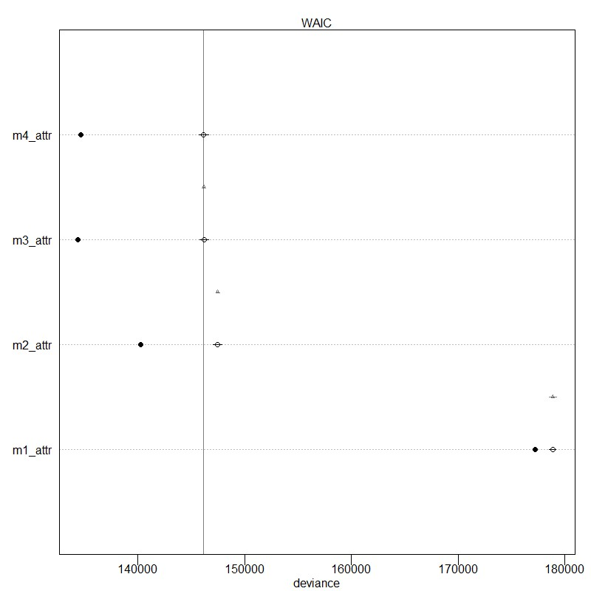

**Figure S35**. Out of sample predictive accuracy, attractiveness, model based on individual ratings.

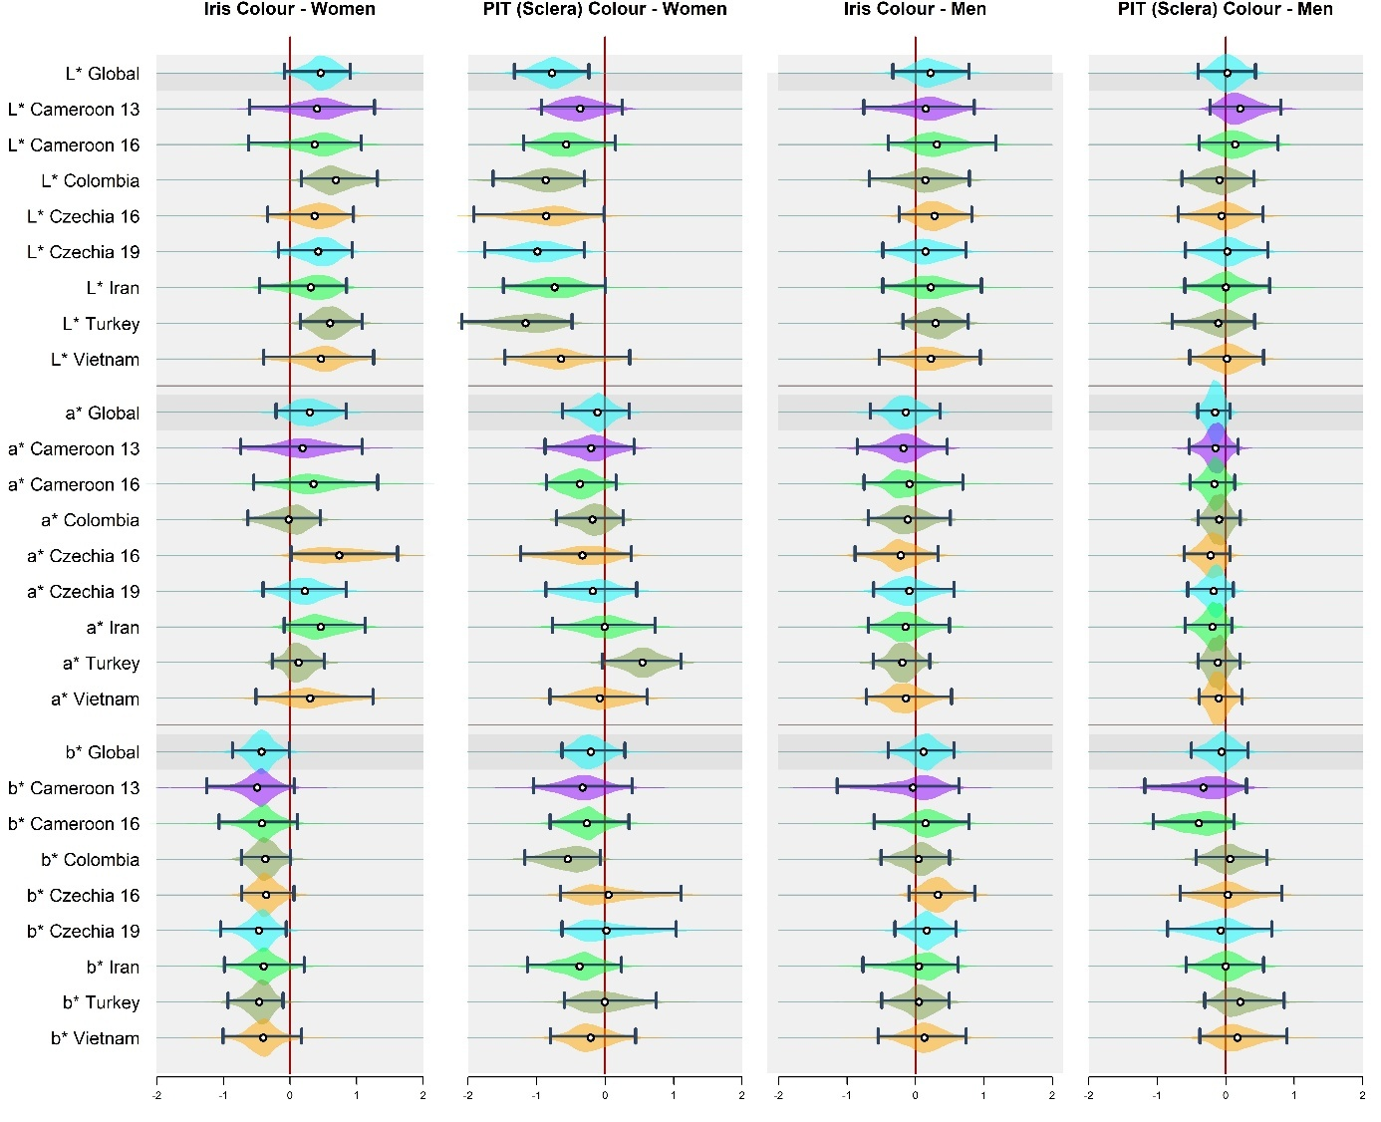

**Figure S36**. Posterior distributions of parameter values, model estimated how individual ratings of attractiveness were predicted by colour of iris and peri-iridal tissues in women (left) and men (right). For more detailed information please see caption of Figure 2 in the article.

##### 5.3.1.1. Standard deviations:

In the plot below:

**σᵗ (sigma_t):** Standard deviation of face-specific intercepts. This parameter reflects the extent to which attractiveness ratings vary due to unobserved characteristics of individual faces, beyond the effects of the measured predictors. Higher values indicate greater face-to-face variability not explained by the included predictors.

**σʳ (sigma_r):** Standard deviation of rater-specific intercepts. This term captures variation in overall rating tendencies across raters – that is, differences in how raters use the scale on average. A higher value suggests greater variability across raters, independent of target characteristics.

In Model 4, **σʳ** is estimated separately for every predictor (captures level of inter-rater variance for rater-specific slopes). In that case, the first **σʳ** corresponds to intercept.

Generally, if **σʳ** M2 (and **σʳ**: intercept in M4) is larger, then inter-rater differences are more influential than differences between faces.

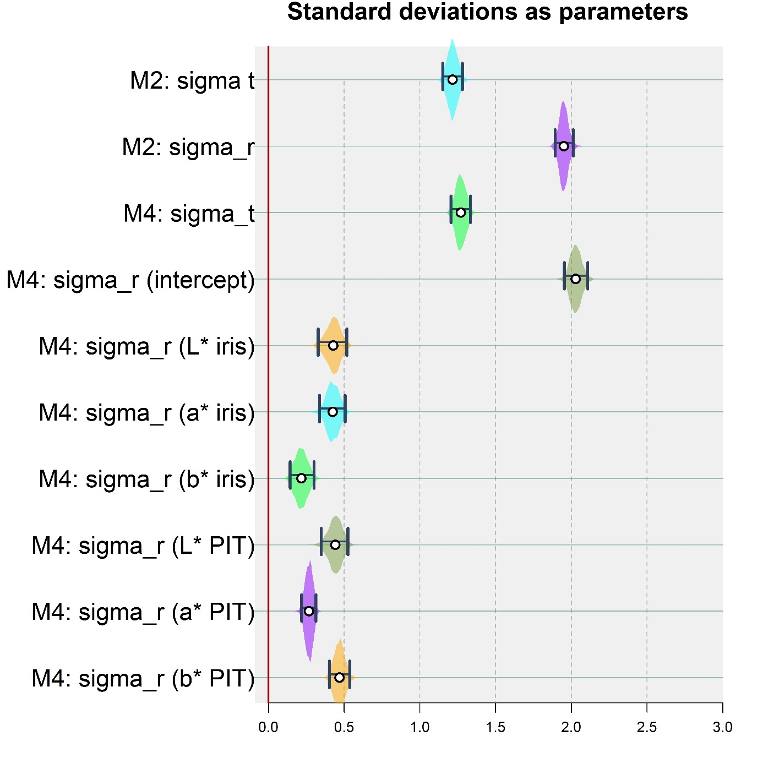**Figure S37**. Distribution of standard deviations for raters (sigma_r) and targets (sigma_t).

#### Although the **σʳ** values are larger, the difference is relatively modest. Therefore, while pooling across raters may mask some individual variability, model predictions are expected to remain similar between approaches that use aggregated ratings and those that treat individual ratings as the response variable.

#### 5.3.2. Sextypicality

WAIC (out of sample predictive accuracy) model comparison reveals that models 4 and 3 are effectively identical, outperforming the other two models.

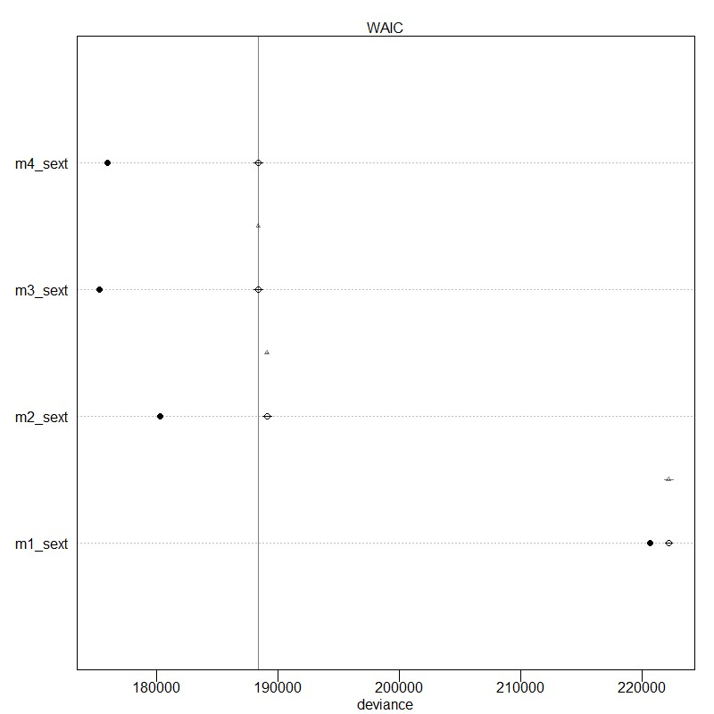

**Figure S38**. Out of sample predictive accuracy, sextypicality, model based on individual ratings.

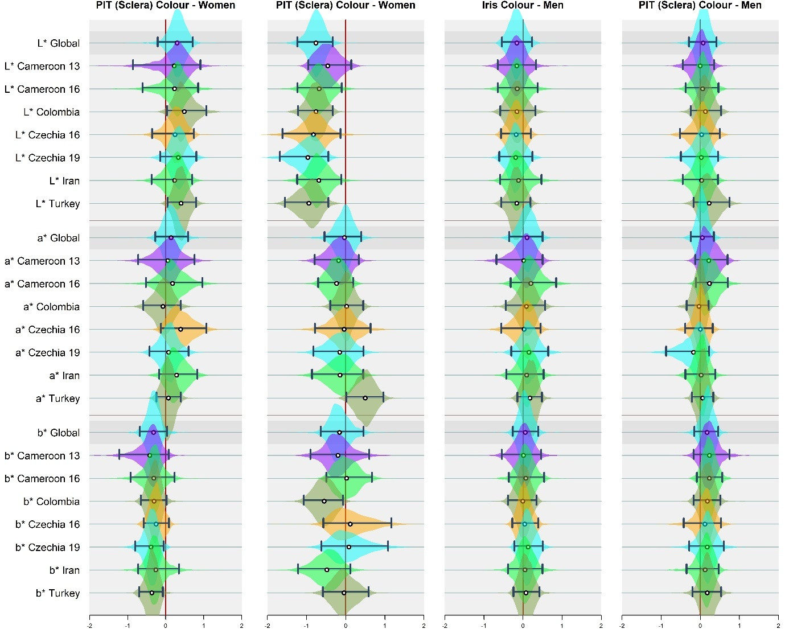

**Figure S39**. Posterior distributions of parameter values, model estimated how individual ratings of sextypicality (femininity in women, masculinity in men) were predicted by colour of iris and peri-iridal tissues in women (left) and men (right). For more detailed information please see caption of Figure 3 in the article.

##### 5.3.2.1. Standard deviations:

[Same layout as above]

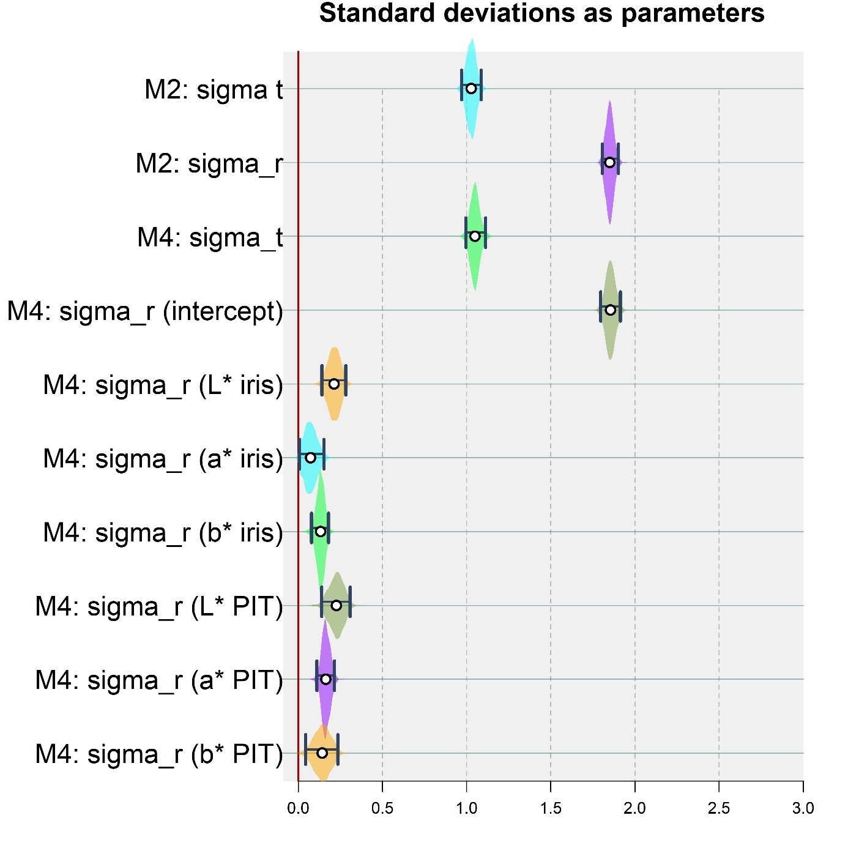**Figure S40**. Distribution of standard deviations for raters (sigma_r) and targets (sigma_t).

## Section 6: Models with nonlinear terms – results report:

Below, we present: (a) transcriptions of selected models with nonlinear terms, along with their analogous linear counterparts; (b) results of model comparison based on the Widely Applicable Information Criterion (WAIC), which evaluates out-of-sample predictive accuracy; and (c) counterfactual plots illustrating predicted changes in perceived attractiveness and sex-typicality as scleral lightness increases from its minimum to maximum observed value (based on the linear models as presented in the manuscript). Note the distinction between posterior predictive plots and counterfactual plots: the former reflects the model's predictions given the observed data, whereas the latter simulate outcomes under hypothetical changes in specific predictors. All predictor variables were either standardised or transformed using a standardised non-zero approach. Each model was fitted under two conditions: (i) standardisation across the pooled sample, and (ii) standardisation conducted separately within each sample.

### 6.1. Considered model layout:

In what follows we report the six models. Please mind that dependent variable is either Attractiveness or Sextypicality and notice that, as a *frozen accident* we do call the PIT “sclera”.

**“M1”** Linear model. This is the layout of the original model that anticipates the association is linear. Repeated here for clarity:

m_1_sext <- ulam(

alist(

Sextypicality ~ normal(mu, sigma), # Or “Attractiveness”

mu <- mu1 + mu2,

mu1 <- A[Sex] +

betas[Grp, 1 + (Sex - 1)*12] + # Intercept (fixed, then per-culture, per-Sex)

BSexTyp[Sex]*MeasSext + betas[Grp, 2 + (Sex - 1)*12]*MeasSext + # Sex typicality

BAsym[Sex]*Asym + betas[Grp, 3 + (Sex - 1)*12]*Asym + # Asymmetry

BDIST [Sex]*DIST + betas[Grp, 4 + (Sex - 1)*12]*DIST + # Distinctiveness

BAge[Sex]*Age + betas[Grp, 5 + (Sex - 1)*12]*Age + # Age

B_L_Skin[Sex]*L_skin + betas[Grp, 6 + (Sex - 1)*12]*L_skin, # Skin lightness

mu2 <- B_L_iris[Sex]*L_iris + betas[Grp, 7 + (Sex - 1)*12]*L_iris + # Iris lightness

B_a_iris[Sex]*a_iris + betas[Grp, 8 + (Sex - 1)*12]*a_iris + # Iris redness

B_b_iris[Sex]*b_iris + betas[Grp, 9 + (Sex - 1)*12]*b_iris + # Iris yellowness

B_L_sclera[Sex]*L_sclera + betas[Grp, 10 + (Sex - 1)*12]*L_sclera + # Sclera lightness

B_a_sclera[Sex]*a_sclera + betas[Grp, 11 + (Sex - 1)*12]*a_sclera + # Sclera redness

B_b_sclera[Sex]*b_sclera + betas[Grp, 12 + (Sex - 1)*12]*b_sclera, # Sclera yellowness

# Non-centered parameterization for betas

transpars> matrix[Grp, 24]:betas <- compose_noncentered(sigma_group, L_Rho_group, z_group),

matrix[24, Grp]:z_group ~ normal(0, 1),

# Hyperpriors for the group-level effects

vector[24]:sigma_group ~ dexp(1),

cholesky_factor_corr[24]:L_Rho_group ~ lkj_corr_cholesky(2),

A[Sex] ~ normal(0, 0.2),

vector[2]:BSexTyp ~ normal(0, 0.5),

vector[2]:BDIST ~ normal(0, 0.5),

vector[2]:BAsym ~ normal(0,0.5),

vector[2]:BAge ~ normal(0, 0.5),

vector[2]:B_L_Skin ~ normal(0, 0.5),

vector[2]:B_L_iris ~ normal(0, 0.5),

vector[2]:B_a_iris ~ normal(0, 0.5),

vector[2]:B_b_iris ~ normal(0, 0.5),

vector[2]:B_L_sclera ~ normal(0, 0.5),

vector[2]:B_a_sclera ~ normal(0, 0.5),

vector[2]:B_b_sclera ~ normal(0, 0.5),

sigma ~ dexp(1),

gq> matrix[24, 24]:Rho_group <<- Chol_to_Corr(L_Rho_group)

), data = data_Sext2, chains = 4, cores = 4, log_lik = T, iter = 5000, control = list(max_treedepth = 18, adapt_delta = 0.99)

)

**“M2”** Quadratic model (model is “forced” to treat of the association between colour/tone and Attractiveness / Sextypicality with quadratic function; exponent = 2):

m_1_2_SQ7_sext <- ulam(

alist(

Sextypicality ~ normal(mu, sigma),

mu <- mu1 + mu2 + mu3 + mu4,

mu1 <- A[Sex] + betas[Grp, 1 + (Sex - 1)*19] + # Intercept (fixed, then per-culture, per-Sex)

BSexTyp[Sex]*MeasSext + betas[Grp, 2 + (Sex - 1)*19]*MeasSext + # Sex typicality

BAsym[Sex]*Asym + betas[Grp, 3 + (Sex - 1)*19]*Asym + # Asymmetry

BDIST [Sex]*DIST + betas[Grp, 4 + (Sex - 1)*19]*DIST + # Distinctiveness

BAge[Sex]*Age + betas[Grp, 5 + (Sex - 1)*19]*Age + # Age

B_L_Skin[Sex]*L_skin + betas[Grp, 6 + (Sex - 1)*19]*L_skin, # Skin lightness

mu2 <- B_L_iris[Sex]*L_iris + betas[Grp, 7 + (Sex - 1)*19]*L_iris + # Iris lightness

B_a_iris[Sex]*a_iris + betas[Grp, 8 + (Sex - 1)*19]*a_iris + # Iris redness

B_b_iris[Sex]*b_iris + betas[Grp, 9 + (Sex - 1)*19]*b_iris + # Iris yellowness

B_L_sclera[Sex]*L_sclera + betas[Grp, 10 + (Sex - 1)*19]*L_sclera + # Sclera lightness

B_a_sclera[Sex]*a_sclera + betas[Grp, 11 + (Sex - 1)*19]*a_sclera + # Sclera redness

B_b_sclera[Sex]*b_sclera + betas[Grp, 12 + (Sex - 1)*19]*b_sclera, # Sclera yellowness

# Adding the selected quadratic terms (fixed + varying)

mu3 <-

B_L_Skin_sq[Sex]*L_skin^2 + betas[Grp, 13 + (Sex - 1)*19]*L_skin^2 + # Skin lightness

B_L_iris_sq[Sex]*L_iris^2 + betas[Grp, 14 + (Sex - 1)*19]*L_iris^2 + # Iris lightness

B_a_iris_sq[Sex]*a_iris^2 + betas[Grp, 15 + (Sex - 1)*19]*a_iris^2 + # Iris redness

B_b_iris_sq[Sex]*b_iris^2 + betas[Grp, 16 + (Sex - 1)*19]*b_iris^2, # Iris yellowness

mu4 <-

B_L_sclera_sq[Sex]*L_sclera^2 + betas[Grp, 17 + (Sex - 1)*19]*L_sclera^2 + # Sclera lightness

B_a_sclera_sq[Sex]*a_sclera^2 + betas[Grp, 18 + (Sex - 1)*19]*a_sclera^2 + # Sclera redness

B_b_sclera_sq[Sex]*b_sclera^2 + betas[Grp, 19 + (Sex - 1)*19]*b_sclera^2, # Sclera yellowness

# Non-centered parameterization for betas

transpars> matrix[Grp, 38]:betas <- compose_noncentered(sigma_group, L_Rho_group, z_group),

matrix[38, Grp]:z_group ~ normal(0, 1),

# Hyperpriors for the group-level effects

vector[38]:sigma_group ~ dexp(1),

cholesky_factor_corr[38]:L_Rho_group ~ lkj_corr_cholesky(2),

A[Sex] ~ normal(0, 0.2),

vector[2]:BSexTyp ~ normal(0, 0.5),

vector[2]:BDIST ~ normal(0, 0.5),

vector[2]:BAsym ~ normal(0,0.5),

vector[2]:BAge ~ normal(0, 0.5),

vector[2]:B_L_Skin ~ normal(0, 0.5),

vector[2]:B_L_iris ~ normal(0, 0.5),

vector[2]:B_a_iris ~ normal(0, 0.5),

vector[2]:B_b_iris ~ normal(0, 0.5),

vector[2]:B_L_sclera ~ normal(0, 0.5),

vector[2]:B_a_sclera ~ normal(0, 0.5),

vector[2]:B_b_sclera ~ normal(0, 0.5),

# Quadratic fixed:

vector[2]:B_L_Skin_sq ~ normal(0, 0.5),

vector[2]:B_L_iris_sq ~ normal(0, 0.5),

vector[2]:B_a_iris_sq ~ normal(0, 0.5),

vector[2]:B_b_iris_sq ~ normal(0, 0.5),

vector[2]:B_L_sclera_sq ~ normal(0, 0.5),

vector[2]:B_a_sclera_sq ~ normal(0, 0.5),

vector[2]:B_b_sclera_sq ~ normal(0, 0.5),

sigma ~ dexp(1),

gq> matrix[38, 38]:Rho_group <<- Chol_to_Corr(L_Rho_group)

), data = data_Sext2, chains = 8, cores = 8, log_lik = T, iter = 2500, control = list(max_treedepth = 18, adapt_delta = 0.99)

)

**“M3”** Linear terms where appropriate, terms with free exponent everywhere else (mind to use the edited [always non-zero] variables where needed). In case there is a free exponent, linear exponent is not considered:

m_1_3_only_varying_sext <- ulam(

alist(

Sextypicality ~ normal(mu, sigma),

mu <- mu1 + mu2 + mu3,

mu1 <- A[Sex] + betas[Grp, 1 + (Sex - 1)*12] + # Intercept (fixed, then per-culture, per-Sex)

BSexTyp[Sex]*MeasSext + betas[Grp, 2 + (Sex - 1)*12]*MeasSext + # Sex typicality

BAsym[Sex]*Asym + betas[Grp, 3 + (Sex - 1)*12]*Asym + # Asymmetry

BDIST [Sex]*DIST + betas[Grp, 4 + (Sex - 1)*12]*DIST + # Distinctiveness

BAge[Sex]*Age + betas[Grp, 5 + (Sex - 1)*12]*Age, # Age

mu2 <-

B_L_Skin_var[Sex]*L_skin_nz^E_skin_L + betas[Grp, 6 + (Sex - 1)*12]*L_skin_nz^E_skin_L + # Skin lightness

B_L_iris_var[Sex]*L_iris_nz^E_iris_L + betas[Grp, 7 + (Sex - 1)*12]*L_iris_nz^E_iris_L + # Iris lightness

B_a_iris_var[Sex]*a_iris_nz^E_iris_a + betas[Grp, 8 + (Sex - 1)*12]*a_iris_nz^E_iris_a + # Iris redness

B_b_iris_var[Sex]*b_iris_nz^E_iris_b + betas[Grp, 9 + (Sex - 1)*12]*b_iris_nz^E_iris_b, # Iris yellowness

mu3 <-

B_L_sclera_var[Sex]*L_sclera_nz^E_sclera_L + betas[Grp, 10 + (Sex - 1)*12]*L_sclera_nz^E_sclera_L + # Sclera lightness

B_a_sclera_var[Sex]*a_sclera_nz^E_sclera_a + betas[Grp, 11 + (Sex - 1)*12]*a_sclera_nz^E_sclera_a + # Sclera redness

B_b_sclera_var[Sex]*b_sclera_nz^E_sclera_b + betas[Grp, 12 + (Sex - 1)*12]*b_sclera_nz^E_sclera_b, # Sclera yellowness

# Za totohle stavu exponent nevaríruje, čili všechno, co odlišuje slopy pro jednotlivé skupiny (a bohužel taky pohlaví),

# musí téct skrze bety, což je nešťastný.

# Non-centered parameterization for betas

transpars> matrix[Grp, 24]:betas <- compose_noncentered(sigma_group, L_Rho_group, z_group),

matrix[24, Grp]:z_group ~ normal(0, 1),

# Hyperpriors for the group-level effects

vector[24]:sigma_group ~ dexp(1),

cholesky_factor_corr[24]:L_Rho_group ~ lkj_corr_cholesky(2),

A[Sex] ~ normal(0, 0.2),

vector[2]:BSexTyp ~ normal(0, 0.5),

vector[2]:BDIST ~ normal(0, 0.5),

vector[2]:BAsym ~ normal(0,0.5),

vector[2]:BAge ~ normal(0, 0.5),

vector[2]:B_L_Skin_var ~ normal(0, 0.5),

vector[2]:B_L_iris_var ~ normal(0, 0.5),

vector[2]:B_a_iris_var ~ normal(0, 0.5),

vector[2]:B_b_iris_var ~ normal(0, 0.5),

vector[2]:B_L_sclera_var ~ normal(0, 0.5),

vector[2]:B_a_sclera_var ~ normal(0, 0.5),

vector[2]:B_b_sclera_var ~ normal(0, 0.5),

# Varying exponent (exponent může bejt jakejkoli, problém byl s tím záporem u samotné proměnné, doufám):

E_skin_L ~ dexp(1),

E_iris_L ~ dexp(1),

E_iris_a ~ dexp(1),

E_iris_b ~ dexp(1),

E_sclera_L ~ dexp(1),

E_sclera_a ~ dexp(1),

E_sclera_b ~ dexp(1),

sigma ~ dexp(1),

gq> matrix[24, 24]:Rho_group <<- Chol_to_Corr(L_Rho_group)

), data = data_Sext2, chains = 4, cores = 4, log_lik = T, iter = 2500, control = list(max_treedepth = 18, adapt_delta = 0.99))

**“M4”** Linear terms where appropriate, terms with free exponent everywhere else. In case there is a free exponent, linear exponent is not considered. With varying exponents estimated separately for women and men; this is to account for potentially different exponents between men and women.

m_1_4_only_varying_sext_sex2 <- ulam(

alist(

Sextypicality ~ normal(mu, sigma),

mu <- mu1 + mu2 + mu3,

mu1 <- A[Sex] + betas[Grp, 1 + (Sex - 1)*12] + # Intercept (fixed, then per-culture, per-Sex)

BSexTyp[Sex]*MeasSext + betas[Grp, 2 + (Sex - 1)*12]*MeasSext + # Sex typicality

BAsym[Sex]*Asym + betas[Grp, 3 + (Sex - 1)*12]*Asym + # Asymmetry

BDIST [Sex]*DIST + betas[Grp, 4 + (Sex - 1)*12]*DIST + # Distinctiveness

BAge[Sex]*Age + betas[Grp, 5 + (Sex - 1)*12]*Age, # Age

mu2 <-

B_L_Skin_var[Sex]*L_skin_nz^E_skin_L[Sex] + betas[Grp, 6 + (Sex - 1)*12]*L_skin_nz^E_skin_L[Sex] + # Skin lightness

B_L_iris_var[Sex]*L_iris_nz^E_iris_L[Sex] + betas[Grp, 7 + (Sex - 1)*12]*L_iris_nz^E_iris_L[Sex] + # Iris lightness

B_a_iris_var[Sex]*a_iris_nz^E_iris_a[Sex] + betas[Grp, 8 + (Sex - 1)*12]*a_iris_nz^E_iris_a[Sex]+ # Iris redness

B_b_iris_var[Sex]*b_iris_nz^E_iris_b[Sex] + betas[Grp, 9 + (Sex - 1)*12]*b_iris_nz^E_iris_b[Sex], # Iris yellowness

mu3 <-

B_L_sclera_var[Sex]*L_sclera_nz^E_sclera_L[Sex] + betas[Grp, 10 + (Sex - 1)*12]*L_sclera_nz^E_sclera_L[Sex] + # Sclera lightness

B_a_sclera_var[Sex]*a_sclera_nz^E_sclera_a[Sex] + betas[Grp, 11 + (Sex - 1)*12]*a_sclera_nz^E_sclera_a[Sex] + # Sclera redness

B_b_sclera_var[Sex]*b_sclera_nz^E_sclera_b[Sex] + betas[Grp, 12 + (Sex - 1)*12]*b_sclera_nz^E_sclera_b[Sex], # Sclera yellowness

# Za totohle stavu exponent nevaríruje, čili všechno, co odlišuje slopy pro jednotlivé skupiny (a bohužel taky pohlaví),

# musí téct skrze bety, což je nešťastný.

# Non-centered parameterization for betas

transpars> matrix[Grp, 24]:betas <- compose_noncentered(sigma_group, L_Rho_group, z_group),

matrix[24, Grp]:z_group ~ normal(0, 1),

# Hyperpriors for the group-level effects

vector[24]:sigma_group ~ dexp(1),

cholesky_factor_corr[24]:L_Rho_group ~ lkj_corr_cholesky(2),

A[Sex] ~ normal(0, 0.2),

vector[2]:BSexTyp ~ normal(0, 0.5),

vector[2]:BDIST ~ normal(0, 0.5),

vector[2]:BAsym ~ normal(0,0.5),

vector[2]:BAge ~ normal(0, 0.5),

vector[2]:B_L_Skin_var ~ normal(0, 0.5),

vector[2]:B_L_iris_var ~ normal(0, 0.5),

vector[2]:B_a_iris_var ~ normal(0, 0.5),

vector[2]:B_b_iris_var ~ normal(0, 0.5),

vector[2]:B_L_sclera_var ~ normal(0, 0.5),

vector[2]:B_a_sclera_var ~ normal(0, 0.5),

vector[2]:B_b_sclera_var ~ normal(0, 0.5),

# Varying exponent:

vector[2]:E_skin_L ~ dexp(1),

vector[2]:E_iris_L ~ dexp(1),

vector[2]:E_iris_a ~ dexp(1),

vector[2]:E_iris_b ~ dexp(1),

vector[2]:E_sclera_L ~ dexp(1),

vector[2]:E_sclera_a ~ dexp(1),

vector[2]:E_sclera_b ~ dexp(1),

sigma ~ dexp(1),

gq> matrix[24, 24]:Rho_group <<- Chol_to_Corr(L_Rho_group)

), data = data_Sext2, chains = 4, cores = 4, log_lik = T, iter = 2500, control = list(max_treedepth = 18, adapt_delta = 0.99))

**“M5”** Both linear term and term with “free exponent” for all the colour-related variables. This model is predicted to perform bad if linear term described the association reliably. Varying exponents (as parameters) are estimated for men and women as **not** divided.

m_1_5_FREE_and_LINN_sext <- ulam(

alist(

Sextypicality ~ normal(mu, sigma),

mu <- mu1 + mu2 + mu3 + mu4,

mu1 <- A[Sex] + betas[Grp, 1 + (Sex - 1)*19] + # Intercept (fixed, then per-culture, per-Sex)

BSexTyp[Sex]*MeasSext + betas[Grp, 2 + (Sex - 1)*19]*MeasSext + # Sex typicality

BAsym[Sex]*Asym + betas[Grp, 3 + (Sex - 1)*19]*Asym + # Asymmetry

BDIST [Sex]*DIST + betas[Grp, 4 + (Sex - 1)*19]*DIST + # Distinctiveness

BAge[Sex]*Age + betas[Grp, 5 + (Sex - 1)*19]*Age + # Age

B_L_Skin[Sex]*L_skin + betas[Grp, 6 + (Sex - 1)*19]*L_skin, # Skin lightness

mu2 <- B_L_iris[Sex]*L_iris + betas[Grp, 7 + (Sex - 1)*19]*L_iris + # Iris lightness

B_a_iris[Sex]*a_iris + betas[Grp, 8 + (Sex - 1)*19]*a_iris + # Iris redness

B_b_iris[Sex]*b_iris + betas[Grp, 9 + (Sex - 1)*19]*b_iris + # Iris yellowness

B_L_sclera[Sex]*L_sclera + betas[Grp, 10 + (Sex - 1)*19]*L_sclera + # Sclera lightness

B_a_sclera[Sex]*a_sclera + betas[Grp, 11 + (Sex - 1)*19]*a_sclera + # Sclera redness

B_b_sclera[Sex]*b_sclera + betas[Grp, 12 + (Sex - 1)*19]*b_sclera, # Sclera yellowness

mu3 <-

B_L_Skin_var[Sex]*L_skin_nz^E_skin_L + betas[Grp, 6 + (Sex - 1)*19]*L_skin_nz^E_skin_L + # Skin lightness

B_L_iris_var[Sex]*L_iris_nz^E_iris_L + betas[Grp, 7 + (Sex - 1)*19]*L_iris_nz^E_iris_L + # Iris lightness

B_a_iris_var[Sex]*a_iris_nz^E_iris_a + betas[Grp, 8 + (Sex - 1)*19]*a_iris_nz^E_iris_a + # Iris redness

B_b_iris_var[Sex]*b_iris_nz^E_iris_b + betas[Grp, 9 + (Sex - 1)*19]*b_iris_nz^E_iris_b, # Iris yellowness

mu4 <-

B_L_sclera_var[Sex]*L_sclera_nz^E_sclera_L + betas[Grp, 10 + (Sex - 1)*19]*L_sclera_nz^E_sclera_L + # Sclera lightness

B_a_sclera_var[Sex]*a_sclera_nz^E_sclera_a + betas[Grp, 11 + (Sex - 1)*19]*a_sclera_nz^E_sclera_a + # Sclera redness

B_b_sclera_var[Sex]*b_sclera_nz^E_sclera_b + betas[Grp, 12 + (Sex - 1)*19]*b_sclera_nz^E_sclera_b, # Sclera yellowness

# Non-centered parameterization for betas

transpars> matrix[Grp, 38]:betas <- compose_noncentered(sigma_group, L_Rho_group, z_group),

matrix[38, Grp]:z_group ~ normal(0, 1),

# Hyperpriors for the group-level effects

vector[38]:sigma_group ~ dexp(1),

cholesky_factor_corr[38]:L_Rho_group ~ lkj_corr_cholesky(2),

A[Sex] ~ normal(0, 0.2),

vector[2]:BSexTyp ~ normal(0, 0.5),

vector[2]:BDIST ~ normal(0, 0.5),

vector[2]:BAsym ~ normal(0,0.5),

vector[2]:BAge ~ normal(0, 0.5),

vector[2]:B_L_Skin ~ normal(0, 0.5),

vector[2]:B_L_iris ~ normal(0, 0.5),

vector[2]:B_a_iris ~ normal(0, 0.5),

vector[2]:B_b_iris ~ normal(0, 0.5),

vector[2]:B_L_sclera ~ normal(0, 0.5),

vector[2]:B_a_sclera ~ normal(0, 0.5),

vector[2]:B_b_sclera ~ normal(0, 0.5),

# Free exponents - priors:

E_skin_L ~ dexp(1),

E_iris_L ~ dexp(1),

E_iris_a ~ dexp(1),

E_iris_b ~ dexp(1),

E_sclera_L ~ dexp(1),

E_sclera_a ~ dexp(1),

E_sclera_b ~ dexp(1),

# Free exponent's betas - priors:

vector[2]:B_L_Skin_var ~ normal(0, 0.5),

vector[2]:B_L_iris_var ~ normal(0, 0.5),

vector[2]:B_a_iris_var ~ normal(0, 0.5),

vector[2]:B_b_iris_var ~ normal(0, 0.5),

vector[2]:B_L_sclera_var ~ normal(0, 0.5),

vector[2]:B_a_sclera_var ~ normal(0, 0.5),

vector[2]:B_b_sclera_var ~ normal(0, 0.5),

sigma ~ dexp(1),

gq> matrix[38, 38]:Rho_group <<- Chol_to_Corr(L_Rho_group)

), data = data_Sext2, chains = 4, cores = 4, log_lik = T, iter = 2500, control = list(max_treedepth = 18, adapt_delta = 0.99))

**“M6”** Both linear term and term with “free exponent” for all the colour-related variables. This model is predicted to perform bad if linear term described the association reliably. Varying exponents (as parameters) are estimated for men and women as **divided**.

m_1_6_FREE_MF_sext <- ulam(

alist(

Sextypicality ~ normal(mu, sigma),

mu <- mu1 + mu2 + mu3 + mu4,

mu1 <- A[Sex] + betas[Grp, 1 + (Sex - 1)*19] + # Intercept (fixed, then per-culture, per-Sex)

BSexTyp[Sex]*MeasSext + betas[Grp, 2 + (Sex - 1)*19]*MeasSext + # Sex typicality

BAsym[Sex]*Asym + betas[Grp, 3 + (Sex - 1)*19]*Asym + # Asymmetry

BDIST [Sex]*DIST + betas[Grp, 4 + (Sex - 1)*19]*DIST + # Distinctiveness

BAge[Sex]*Age + betas[Grp, 5 + (Sex - 1)*19]*Age + # Age

B_L_Skin[Sex]*L_skin + betas[Grp, 6 + (Sex - 1)*19]*L_skin, # Skin lightness

mu2 <- B_L_iris[Sex]*L_iris + betas[Grp, 7 + (Sex - 1)*19]*L_iris + # Iris lightness

B_a_iris[Sex]*a_iris + betas[Grp, 8 + (Sex - 1)*19]*a_iris + # Iris redness

B_b_iris[Sex]*b_iris + betas[Grp, 9 + (Sex - 1)*19]*b_iris + # Iris yellowness

B_L_sclera[Sex]*L_sclera + betas[Grp, 10 + (Sex - 1)*19]*L_sclera + # Sclera lightness

B_a_sclera[Sex]*a_sclera + betas[Grp, 11 + (Sex - 1)*19]*a_sclera + # Sclera redness

B_b_sclera[Sex]*b_sclera + betas[Grp, 12 + (Sex - 1)*19]*b_sclera, # Sclera yellowness

mu3 <-

B_L_Skin_var[Sex]*L_skin_nz^E_skin_L[Sex] + betas[Grp, 6 + (Sex - 1)*19]*L_skin_nz^E_skin_L[Sex] + # Skin lightness

B_L_iris_var[Sex]*L_iris_nz^E_iris_L[Sex] + betas[Grp, 7 + (Sex - 1)*19]*L_iris_nz^E_iris_L[Sex] + # Iris lightness

B_a_iris_var[Sex]*a_iris_nz^E_iris_a[Sex] + betas[Grp, 8 + (Sex - 1)*19]*a_iris_nz^E_iris_a[Sex] + # Iris redness

B_b_iris_var[Sex]*b_iris_nz^E_iris_b[Sex] + betas[Grp, 9 + (Sex - 1)*19]*b_iris_nz^E_iris_b[Sex], # Iris yellowness

mu4 <-

B_L_sclera_var[Sex]*L_sclera_nz^E_sclera_L[Sex] + betas[Grp, 10 + (Sex - 1)*19]*L_sclera_nz^E_sclera_L[Sex] + # Sclera lightness

B_a_sclera_var[Sex]*a_sclera_nz^E_sclera_a[Sex] + betas[Grp, 11 + (Sex - 1)*19]*a_sclera_nz^E_sclera_a[Sex] + # Sclera redness

B_b_sclera_var[Sex]*b_sclera_nz^E_sclera_b[Sex] + betas[Grp, 12 + (Sex - 1)*19]*b_sclera_nz^E_sclera_b[Sex], # Sclera yellowness

# Non-centered parameterization for betas

transpars> matrix[Grp, 38]:betas <- compose_noncentered(sigma_group, L_Rho_group, z_group),

matrix[38, Grp]:z_group ~ normal(0, 1),

# Hyperpriors for the group-level effects

vector[38]:sigma_group ~ dexp(1),

cholesky_factor_corr[38]:L_Rho_group ~ lkj_corr_cholesky(2),

A[Sex] ~ normal(0, 0.2),

vector[2]:BSexTyp ~ normal(0, 0.5),

vector[2]:BDIST ~ normal(0, 0.5),

vector[2]:BAsym ~ normal(0,0.5),

vector[2]:BAge ~ normal(0, 0.5),

vector[2]:B_L_Skin ~ normal(0, 0.5),

vector[2]:B_L_iris ~ normal(0, 0.5),

vector[2]:B_a_iris ~ normal(0, 0.5),

vector[2]:B_b_iris ~ normal(0, 0.5),

vector[2]:B_L_sclera ~ normal(0, 0.5),

vector[2]:B_a_sclera ~ normal(0, 0.5),

vector[2]:B_b_sclera ~ normal(0, 0.5),

# Free exponents - priors:

vector[2]:E_skin_L ~ dexp(1),

vector[2]:E_iris_L ~ dexp(1),

vector[2]:E_iris_a ~ dexp(1),

vector[2]:E_iris_b ~ dexp(1),

vector[2]:E_sclera_L ~ dexp(1),

vector[2]:E_sclera_a ~ dexp(1),

vector[2]:E_sclera_b ~ dexp(1),

# Free exponent's betas - priors:

vector[2]:B_L_Skin_var ~ normal(0, 0.5),

vector[2]:B_L_iris_var ~ normal(0, 0.5),

vector[2]:B_a_iris_var ~ normal(0, 0.5),

vector[2]:B_b_iris_var ~ normal(0, 0.5),

vector[2]:B_L_sclera_var ~ normal(0, 0.5),

vector[2]:B_a_sclera_var ~ normal(0, 0.5),

vector[2]:B_b_sclera_var ~ normal(0, 0.5),

sigma ~ dexp(1),

gq> matrix[38, 38]:Rho_group <<- Chol_to_Corr(L_Rho_group)

), data = data_Sext2, chains = 4, cores = 4, log_lik = T, iter = 2500, control = list(max_treedepth = 18, adapt_delta = 0.99)

### 6.2. Predictions – Data standardised together

#### 6.2.1. Attractiveness

# WAIC SE dWAIC dSE pWAIC weight

# [M4] m_1_4_only_varying_attr_sex2 2355.3 53.74 0.0 NA 77.7 0.53

# [M3] m_1_3_only_varying_attr 2356.6 53.78 1.4 2.84 76.7 0.27

# [M6] m_1_6_FREE_MF_attr 2359.0 53.46 3.7 7.07 95.9 0.08

# [M1] m_1_attr 2359.0 53.91 3.7 7.16 96.3 0.08

# [M5] m_1_5_FREE_and_LINN_attr 2360.3 53.43 5.1 6.95 95.7 0.04

# [M2] m_1_2_SQ7_attr 2379.6 53.61 24.3 12.76 123.3 0.00

The models with linear terms only and those with various combinations of free exponents and linear term(s) are similarly good in out of sample predictive accuracy. The worst model (with somehow, though not substantially, higher WAIC) is model with a combination of linear and quadratic terms.

Plot below shows distribution of posteriors for free exponents (models M3-M6):

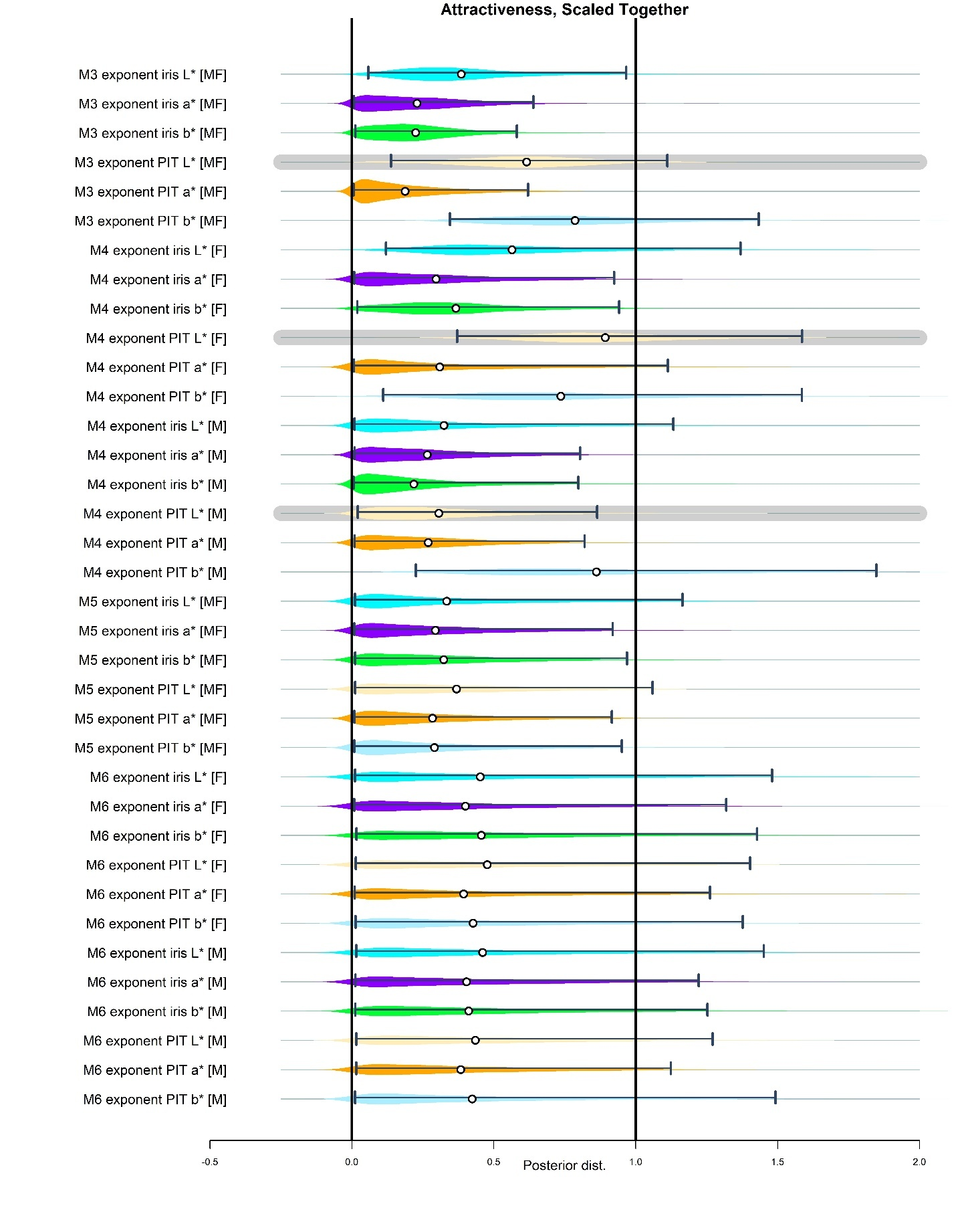

**Figure S41**. Posterior distribution of the parameters that estimates exponent [power] of the association between eye colour related variables and perceived attractiveness. Grey noodle highlights parameters that are relevant for the manuscript (free exponent in the association between PIT L* and perceived attractiveness.

In the model with a free exponent that estimates effects separately for men and women (Model 4), the exponent approaches one where the power term, detailing the association appears relevant – specifically for women (M4 exponent for PIT L* [F]). Model 4 also received the highest relative weight in the WAIC-based model comparison. For men, the estimated exponent is below one; however, the association between variables is likely close to zero and the free exponent approaching zero can be an artefact of a null or weak association.

In models that combine linear terms with terms using a free exponent, the posterior predictions – while favouring an exponent close to one – tend to mirror the shape of the exponential prior (dexp[1]).

Below, we illustrate how the linear model reported in the main manuscript, along with the most parsimonious model among the candidates described above, accounts for the observed variance. Based on the results, we find no evidence supporting an n-shaped association between perceived attractiveness and PIT L* (also referred to as 'scleral lightness' in the relevant literature)."

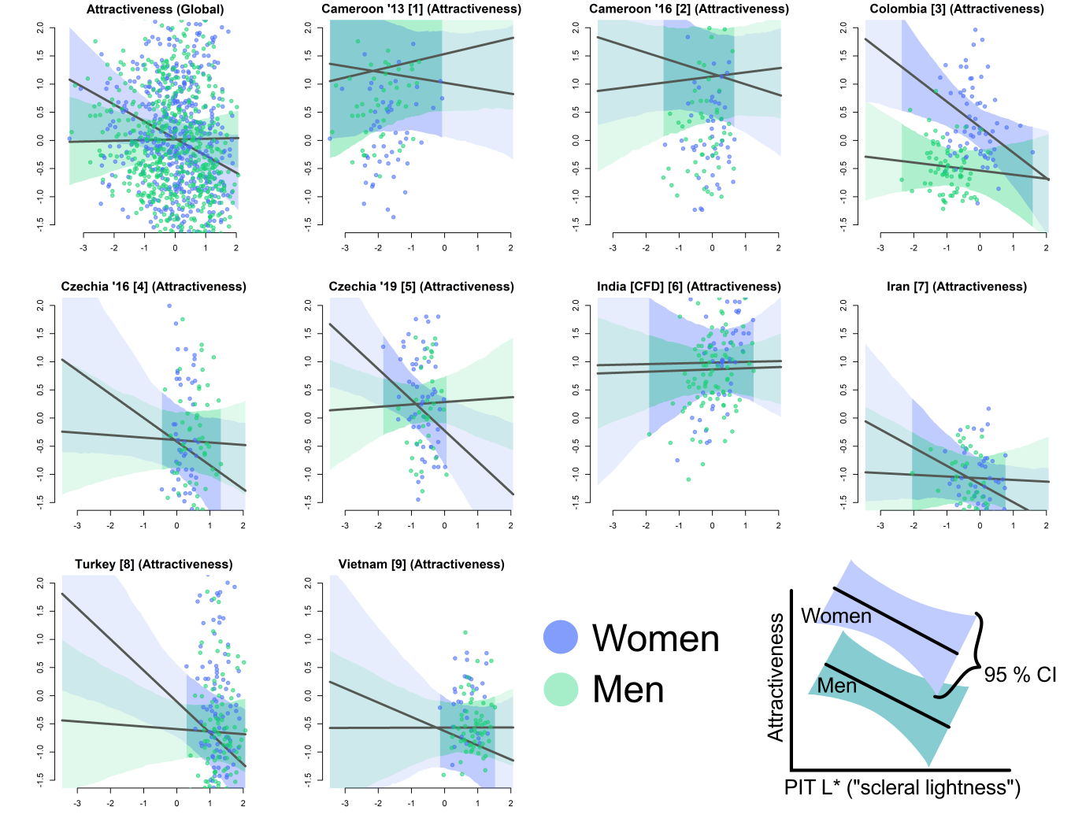

**Figure S42**. Counterfactual predictions on the association between PIT L* and perceived attractiveness (both the variables scaled to zero mean and variance unity across the whole dataset). The plot is based on model M1, which contains just linear terms. Integers in square brackets serve to check whether we referred to a correct sample when plotting. The 95% CI is a pointwise credible interval around the predicted mean. Darker part of the interval refers to the part of the range for which we possess data in the given culture.

#### 6.2.2. Sextypicality

WAIC SE dWAIC dSE pWAIC weight

[M4] m_1_4_only_varying_sext_sex2 2033.4 52.78 0.0 NA 80.7 0.36

[M5] m_1_5_FREE_and_LINN_sext 2033.6 53.84 0.2 6.19 91.6 0.33

[M6] m_1_6_FREE_MF_sext 2034.2 53.81 0.8 6.11 92.1 0.24

[M1] m_1_sext 2037.4 53.88 4.0 6.93 93.4 0.05

[M3] m_1_3_only_varying_sext 2038.6 52.70 5.2 2.81 78.4 0.03

[M2] m_1_2_SQ7_sext 2061.6 53.88 28.2 10.23 114.0 0.00

The pattern mirrors that observed for attractiveness: all models allowing a linear association between eye colour and perceived sex-typicality perform similarly well in terms of out-of-sample predictive accuracy. In contrast, Model 2 – which constrains the association to a quadratic form – is not supported by this comparison.

Below, we present posterior distributions for all parameters estimating the exponent (power) of the association between eye colour-related variables and perceived sex-typicality (i.e., femininity in women, masculinity in men), along with a counterfactual plot based on the model using only linear terms.

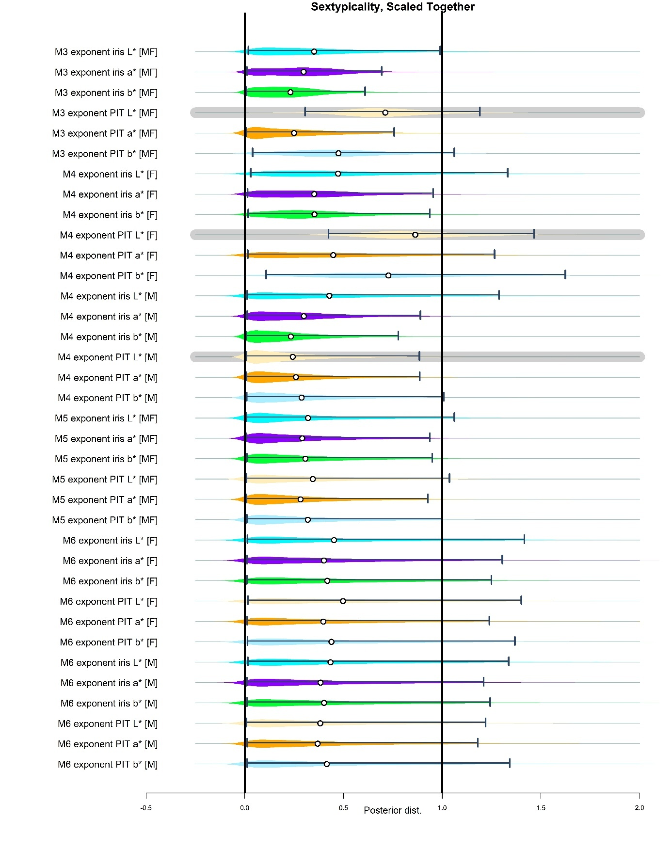

**Figure S43**. Posterior distribution of the parameters that estimates exponent [power] of the association between eye colour related variables and perceived sextypicality (femininity in women, masculinity in men).

We see similar patter as above. Linear association in women is a good approximation of the actual association.

Sextypicality

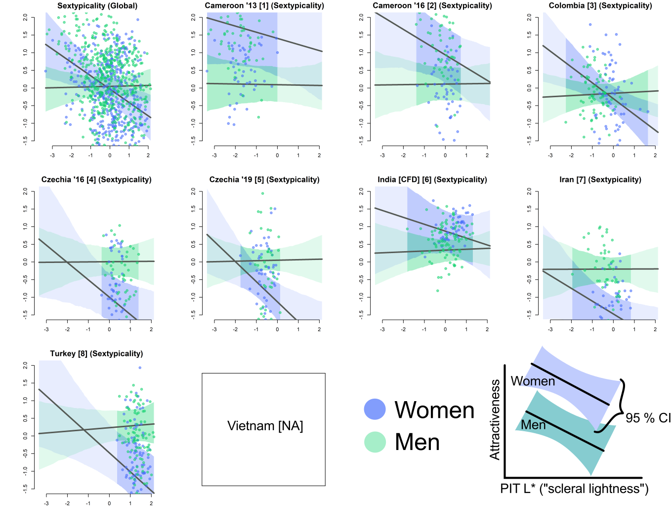

Sextypicality

**Figure S44**. Counterfactual predictions on the association between PIT L* and perceived sextypicality (both the variables scaled to zero mean and variance unity across the whole dataset). The plot is based on model M1 (m_1_sext), which contains just linear terms.

### 6.3. Model predictions – Data standardised separately

Note: separate standardisation should result in “range being similar in every sample”.

#### 6.3.1. Attractiveness

[M3] m_1_3_only_varying_attrSEP 2707.8 48.03 0.0 NA 81.0 0.47

[M4] m_1_4_only_varying_attr_sex2SEP 2708.0 48.15 0.2 2.27 82.5 0.43

[M1] m_1_attrSEP 2711.2 48.15 3.4 8.43 99.9 0.09

[M5] m_1_5_FREE_and_LINN_attrSEP 2717.4 48.24 9.6 7.91 99.3 0.00

[M6] m_1_6_FREE_MF_attrSEP 2717.6 48.21 9.8 7.90 99.4 0.00

[M2] m_1_2_SQ7_attrSEP 2732.8 47.66 25.0 13.15 129.7 0.00

WAIC-based model comparison again shows similar support for several models, including models with free exponents and model that considers the association between perceived attractiveness and eye morphology to be strictly linear. Again, model with obligatorily quadratic association is the least supported one.

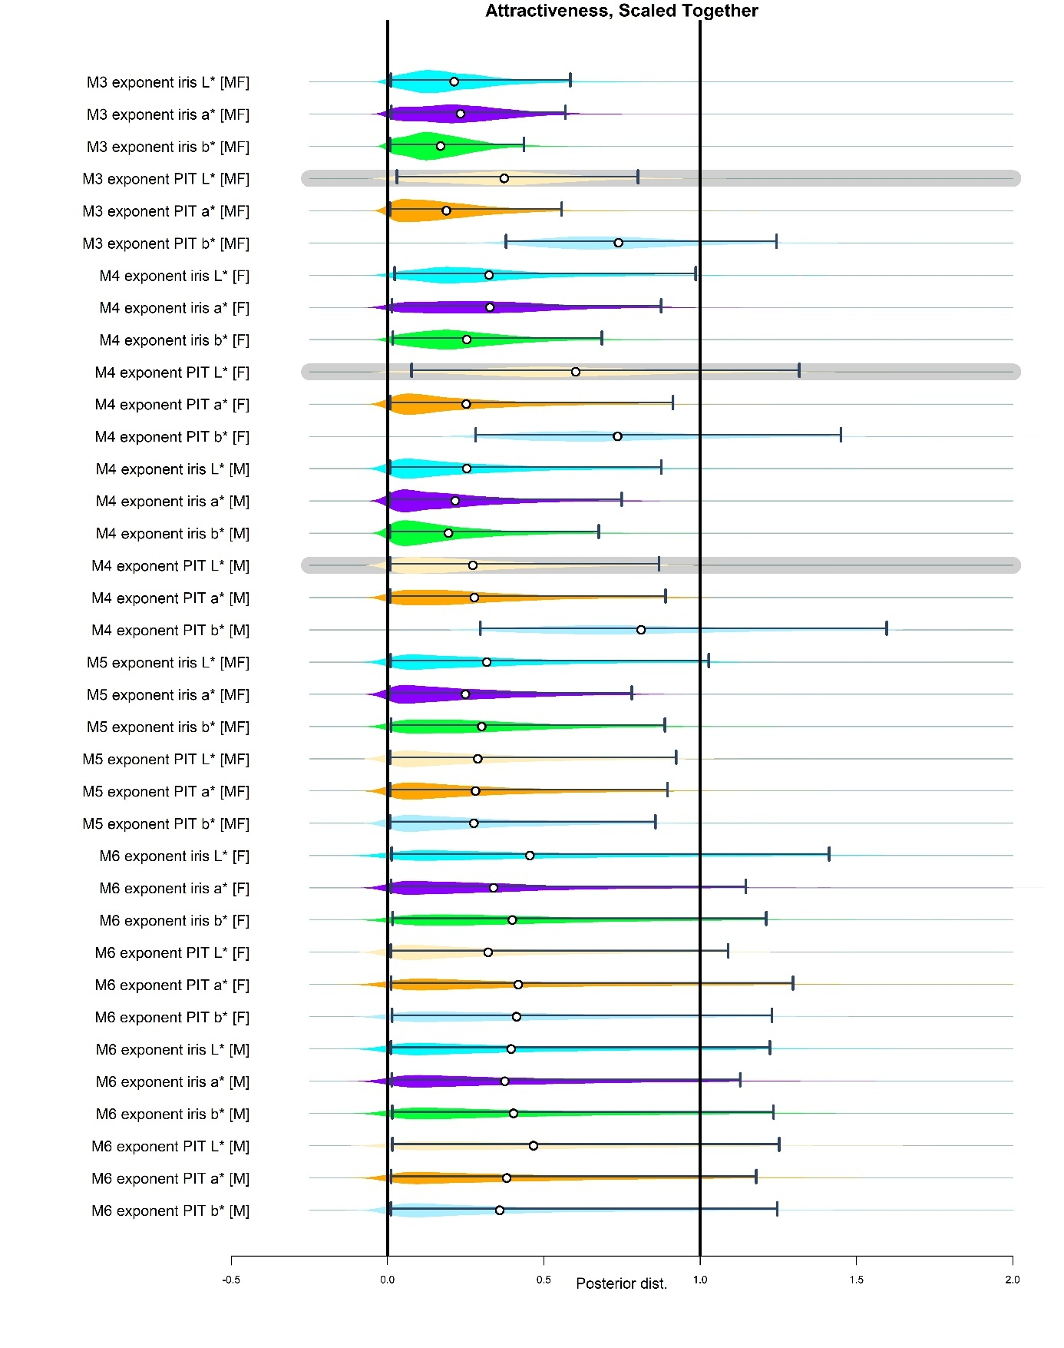**Figure S45**. Posterior distribution of the parameters that estimates exponent [power] of the association between eye colour related variables and perceived attractiveness. As before, no support for the exponent of two is obvious. Model 3 do not predict the exponent of the association being close to zero, probably due to not estimating the exponent separately for men (where the linear association itself is null) and women. In model 4, which allows this estimate the exponent separately for men and women, it approaches one in case of women.

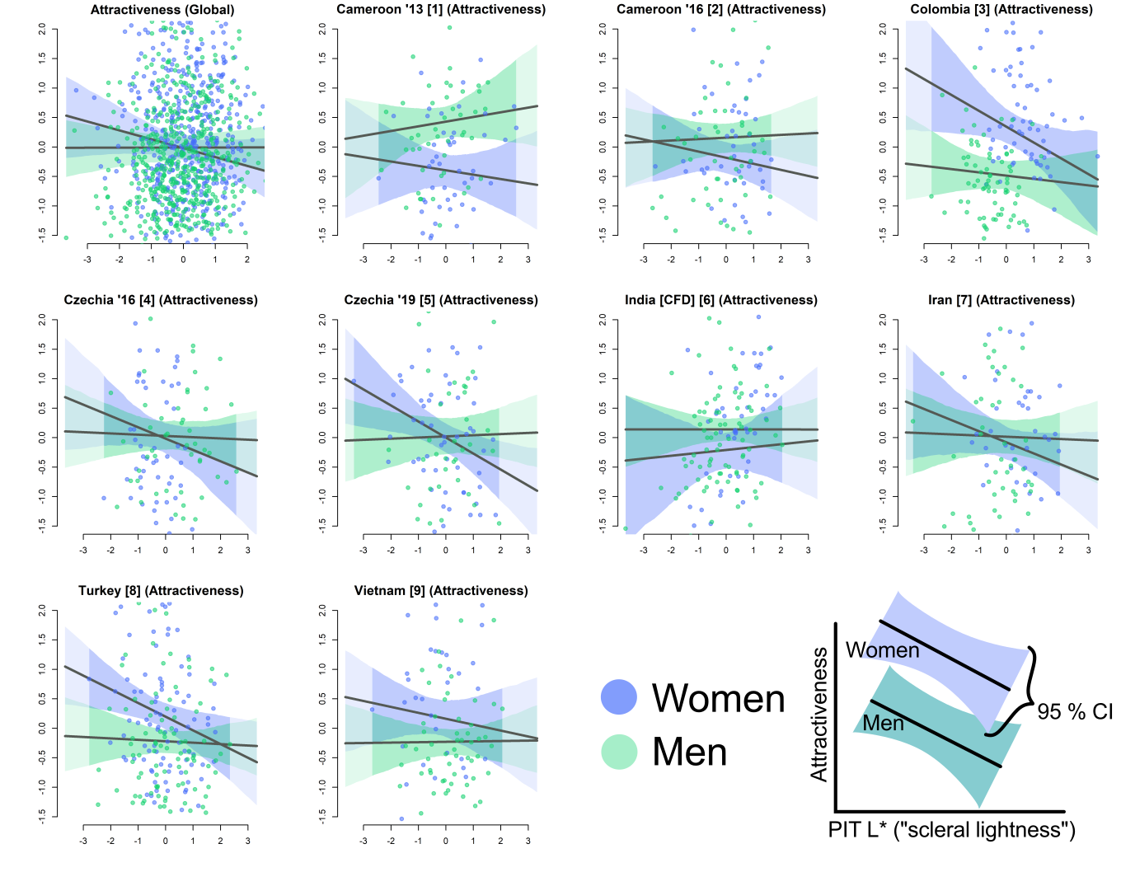

**Figure S46**. Counterfactual predictions on the association between PIT L* and perceived attractiveness (both the variables scaled to zero mean and variance unity separately in each culture). The plot is based on model M1, which contains just linear terms.

#### 6.3.2. Sextypicality

WAIC SE dWAIC dSE pWAIC weight

[M4] m_1_4_only_varying_sext_sex2SEP 2383.4 47.86 0.0 NA 79.2 0.81

[M3] m_1_3_only_varying_sextSEP 2387.3 47.91 3.9 2.47 78.4 0.11

[M1] m_1_sextSEP 2389.0 48.51 5.6 7.54 92.7 0.05

[M6] m_1_6_FREE_QUAD_SEX_sextSEP 2390.8 49.04 7.4 7.19 92.1 0.02

[M5] m_1_5_FREE_QUAD_sextSEP 2392.1 49.01 8.7 7.11 92.5 0.01

[M2] m_1_2_SQ7_sextSEP 2412.9 48.72 29.5 11.93 119.0 0.00

Model with free exponent only is supported by WAIC. Linear model is also partly supported while quadratic one (power = 2) is performing the worst when models are ordered based on out of sample predictive accuracy.

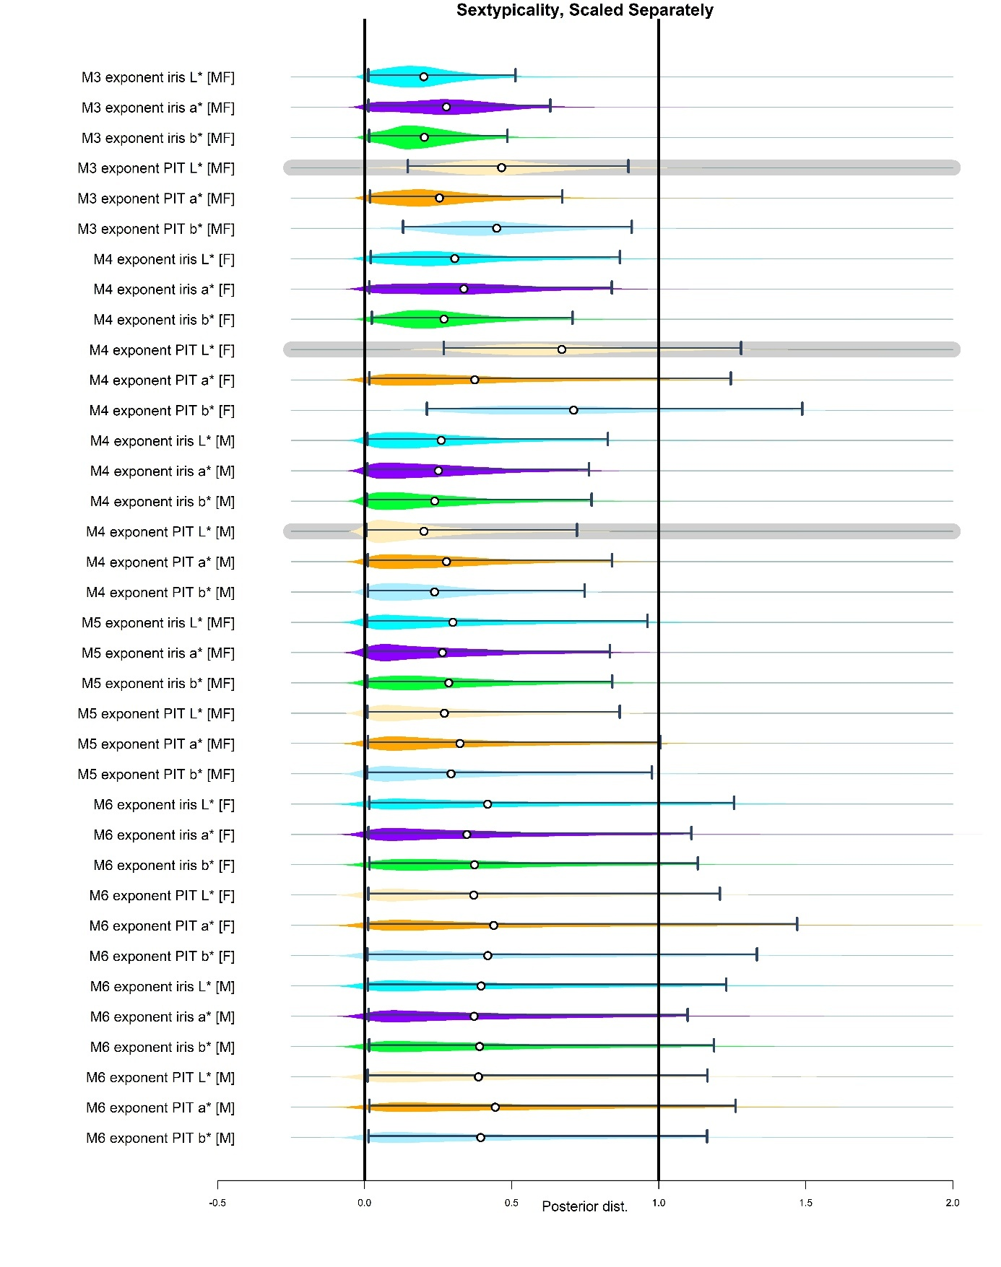

**Figure S47**. Posterior distribution of the parameters that estimates exponent [power] of the association between eye colour related variables and perceived sextypicality.

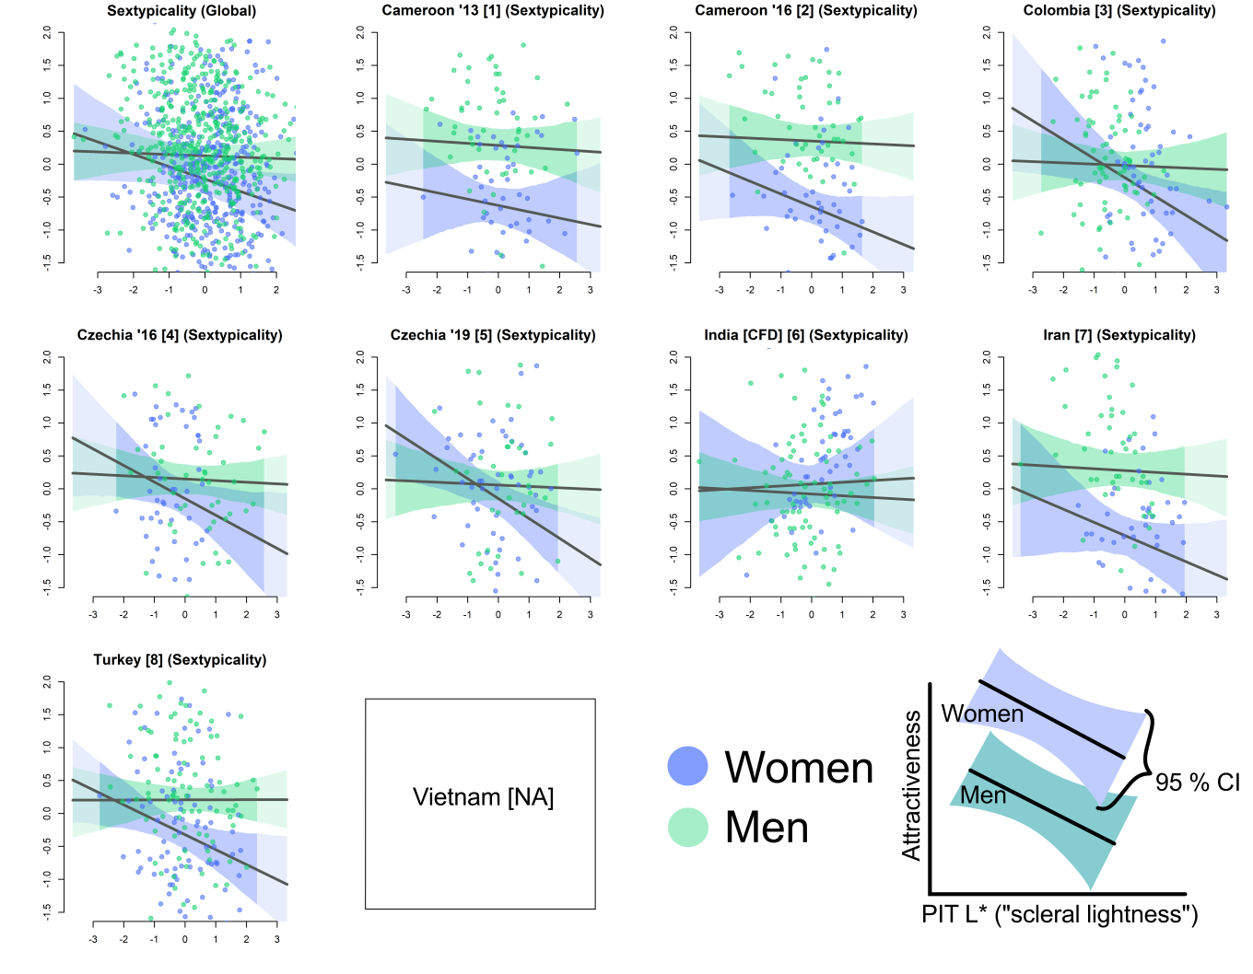

Sextypicality

**Figure S48**. Counterfactual predictions on the association between PIT L* and perceived sextypicality (both the variables scaled to zero mean and variance unity across the whole dataset). The plot is based on model M1, which contains just linear terms.

In all cases, we observe that models with linear terms perform relatively well among the models with free exponents and quadratic terms. Also, the counterfactual plots show that n-shaped association is, contrary to our expectations, unlikely.

## Section 7: Excluding values at the margins – model predictions.

In the manuscript, we report results based on pooled ratings using models that treat the associations between attractiveness or sex-typicality and their predictors as linear. These analyses include the full dataset, with no exclusions for potential outliers. However, to assess the possible influence of outliers as highly influential data points, we conducted an additional analysis excluding extreme observations, defined as values lying outside 1.5 times the interquartile range (IQR), applied separately within each sample.

Below, we present a subset of models fitted to these reduced datasets. Outliers were identified and excluded independently within each cultural sample. Excluding outliers from the pooled dataset, by contrast, tends to disproportionately reduce some samples more than others, potentially biasing the estimated coefficients. For this reason, we retained the approach of identifying outliers within each group. The same model structure as reported in the manuscript was used for this robustness check.

### 7.1. Attractiveness

#### 7.1.1. Standardised together

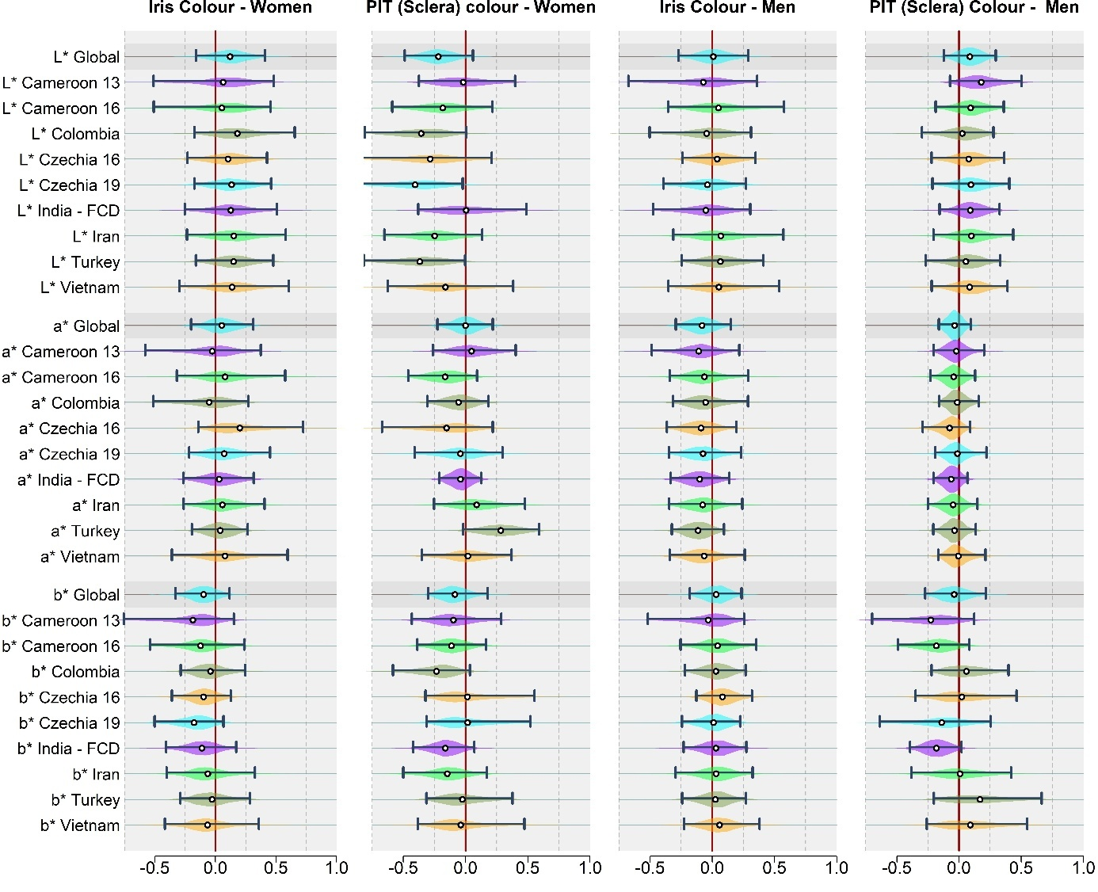

**Figure S49.** Associations between perceived attractiveness and selected eye-colour variables relating to the iris and peri-iridial tissues. Based on dataset with observations that stood more than. Based on the dataset with outliers excluded. Data were standardised across the whole dataset, preserving different ranges of the variables in different samples.

#### 7.1.2. Standardised separately

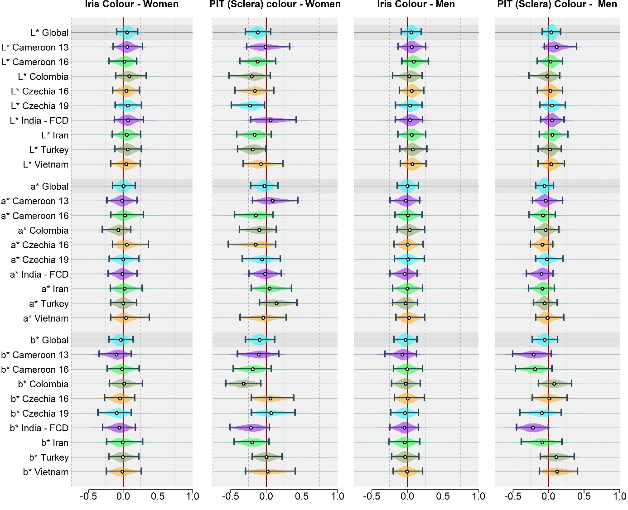

**Figure S50.** Associations between perceived attractiveness and selected eye-colour variables relating to the iris and peri-iridial tissues. Based on dataset with observations that stood more than. Based on the dataset with outliers excluded. Data were standardised separately in every sample which makes the model to consider range in every culture as similar.

### 7.2. Sextypicality

#### 7.2.1. Standardised together

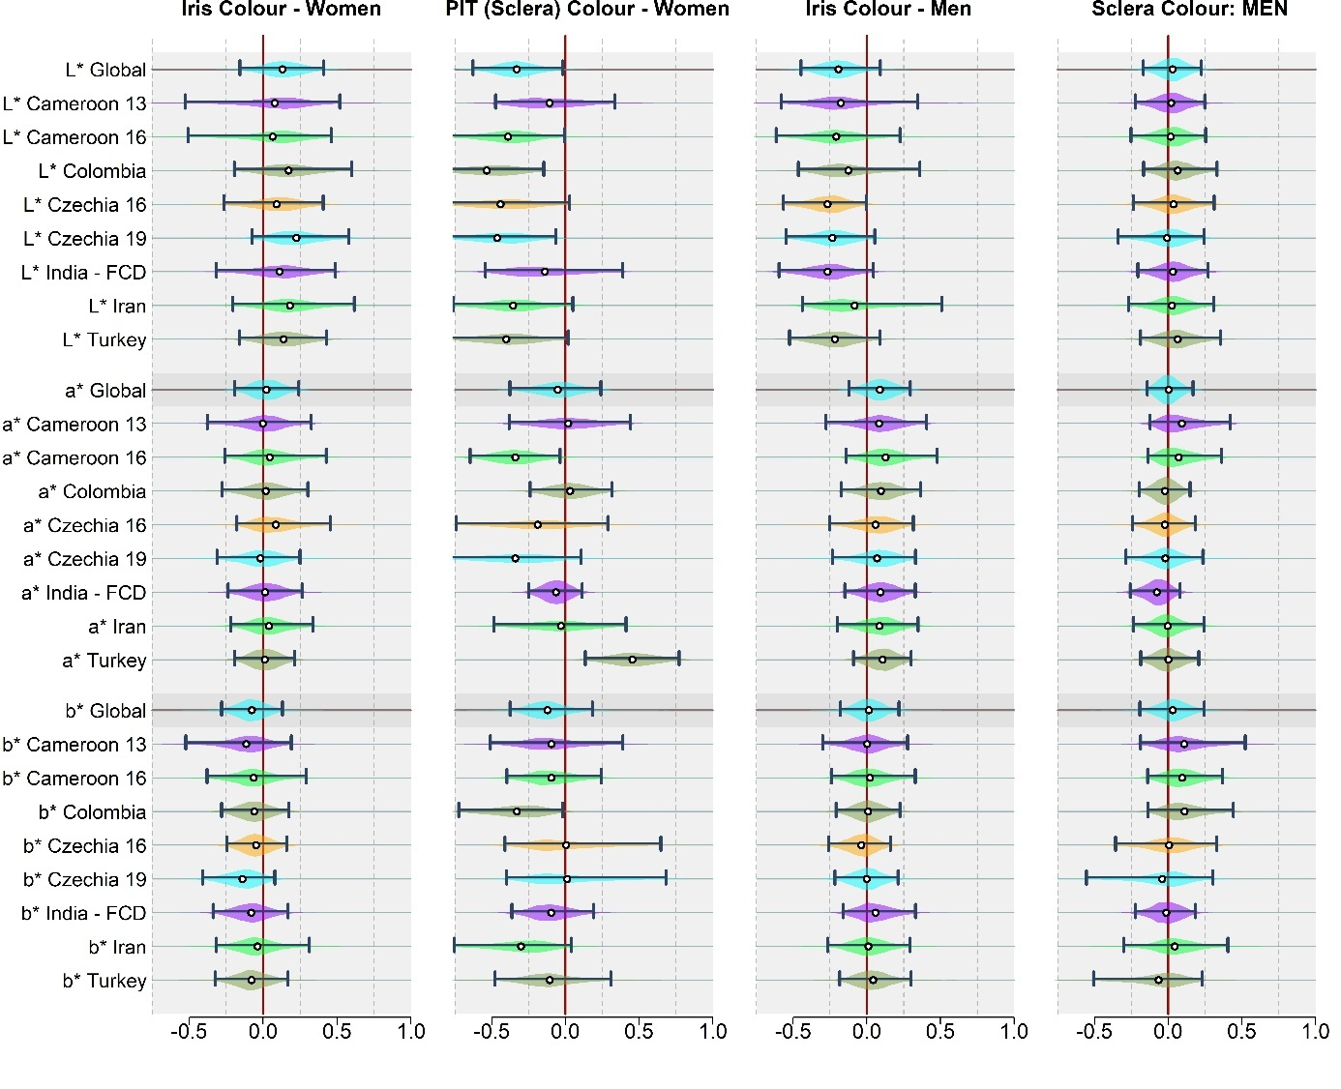**Figure S51.** Associations between perceived sextypicality (femininity of women, masculinity of men) and selected eye-colour variables relating to the iris and peri-iridial tissues. Based on dataset with observations that stood more than. Based on the dataset with outliers excluded. Data were standardised across the whole dataset, preserving different ranges of the variables in different samples.

#### 7.2.2. Standardised separately

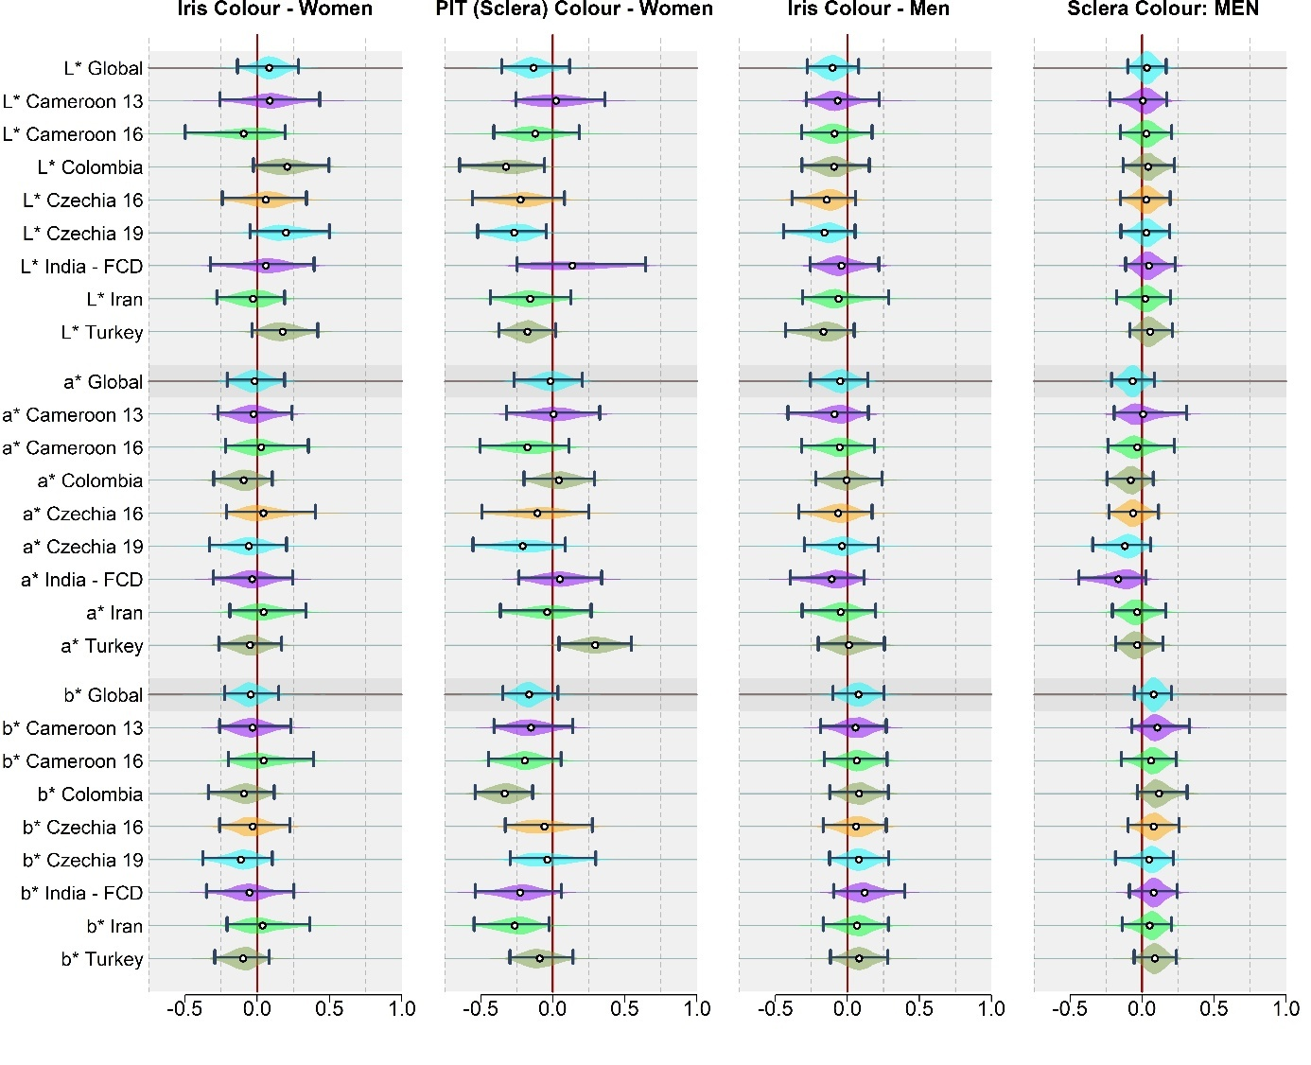

**Figure S52.** Associations between perceived sextypicality (femininity of women, masculinity of men) and selected eye-colour variables relating to the iris and peri-iridial tissues. Based on dataset with observations that stood more than. Based on the dataset with outliers excluded. Data were standardised separately in every sample.

## 8. References

Fiala, V., Třebický, V., Pazhoohi, F., Leongómez, J. D., Tureček, P., Saribay, S. A., Akoko, R. M., & Kleisner, K. (2021). Facial attractiveness and preference of sexual dimorphism: A comparison across five populations. *Evolutionary Human Sciences*, *3*. https://doi.org/10.1017/ehs.2021.33

Pokorný, Š., Pavlovič, O., & Kleisner, K. (2024). Sexual Dimorphism: The Interrelation of Shape and Color. *Archives of Sexual Behavior*, *53*(8), 3255–3265. https://doi.org/10.1007/s10508-024-02918-1